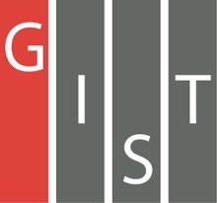

**Gwangju Institute of Science and Technology**

**Official Press Release (https://www.gist.ac.kr/)**

**Section of** Hyo Jung Kim Nayeong Lee

**Public Relations** Section Chief Senior Administrator

(+82) 62-715-2061 (+82) 62-715-2062

**Contact Person** Seung-soo Yoo, Administrator

**for this Article** Section of Public Affairs

062-715-2025

**Release Date** 2020.04.08

**GIST and Korea University sign a business agreement (MoU) to promote AI education and research**

□ Gwangju Institute of Science and Technology (GIST, President Kiseon Kim) and Korea University (President Jin-taek Chung) signed a business agreement (MoU) to promote education and research in the field of artificial intelligence.

∘ To prevent the spread of COVID-19 infections, the MoUs were signed separately at both institutions on April 7, 2020.

∘ The main contents of the agreement include ▲ education and personnel exchanges in the field of artificial intelligence ▲ research and development, technology exchange, and public resource sharing in the field of public announcement ▲ performance expansion in the field of artificial intelligence and the fostering of startups.

□ GIST President Kiseon Kim said, "GIST and Korea University have agreed to produce advanced Ph.D. specialists who will lead Korea's future AI technology powerhouse through the operation of the AI Graduate School. Furthermore, through commercialization leading to the artificial intelligence start-up ecosystem, we will actively contribute to the revitalization of the local economy by training the necessary personnel."

□ Korea University President Jin-taek Chung said, "In the field of artificial intelligence and data science, a major challenge for universities will be to nurture the specialists who will lead the era of the 4th Industrial Revolution. This agreement will serve as an opportunity for valuable exchanges between the two universities to promote artificial intelligence convergence education and research."

□ GIST rrecently signed an agreement with universities, government agencies, and businesses such as Seoul National University, KAIST, Gwangju National University of Education, Korea Internet & Security Agency (KISA), NCsoft, etc. to secure core AI-related capabilities through AI-based industry-academic cooperation and technology exchanges. GIST also plans to open the GIST AI Graduate School in March of this year to train top-notch Ph.Ds. who will lead the research and development of artificial intelligence at home and abroad.

∘ Meanwhile, Korea University operates the AI Graduate School of Artificial Intelligence and trains world-class artificial intelligence experts. Recently, the Data Science Institute was established to lay the foundation for promoting artificial intelligence and data science convergence education and collective convergence research in various fields such as humanities, natural science, applied science, and medical science based on artificial intelligence skills and data science-based technologies.

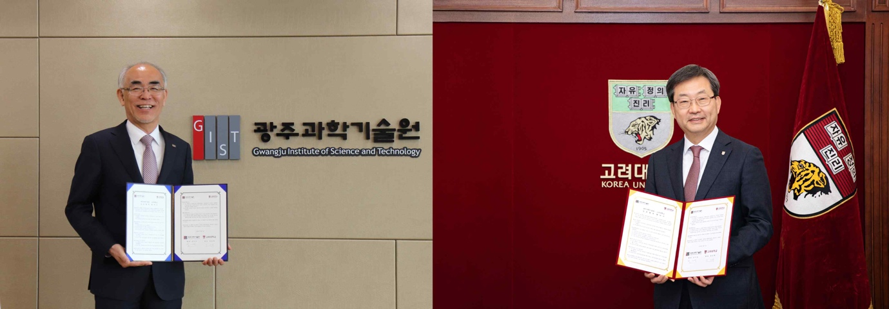

▲ (from left) GIST President Kiseon Kim and Korea University President Jin-taek Chung