

**Gwangju Institute of Science and Technology**

**Official Press Release (https://www.gist.ac.kr/)**

**Section of** Hyo Jung Kim Nayeong Lee

**Public Relations** Section Chief Senior Administrator

(+82) 62-715-2061 (+82) 62-715-2062

**Contact Person** Moon-seop Yoon, Administrator

**for this Article** Section of Public Affairs

+(82) 62-715-2021

**Release Date** 2020.06.30

**Moo-jin Choi, CEO of Nanum Tech Co., Ltd., donated 100 million won to GIST Development Fund**

□ GIST (Gwangju Institute of Science and Technology, President Kiseon Kim) has received 100 million won for the GIST Development Fund from Moo-jin Choi, CEO of Nanum Tech Co., Ltd.

∘ The donation ceremony was held at the GIST President Kiseon Kim's office on June 30, 2020, along with Nanum Tech Co., Ltd., CEO Moo-jin Choi and officials in attendance.

□ At the donation ceremony, CEO Moo-jin Choi said, "I decided to donate because I highly appreciate the infinite growth potential of GIST with its excellent source technology. I hope that this will be used effectively throughout the industry through technology development and investment support, such as industry-academic cooperation utilizing GIST's excellent research results."

□ GIST President Kiseon Kim said, "We are always proud to have the excellent medical device company Nanum Tech in our region. Thank you for believing GIST's growth potential. In the future, we will reward the vitalization of the local economy through better research results and training of local specialized personnel."

∘ Meanwhile, Nanum Tech Co., Ltd., worked with GIST in 2009 to develop and study succeeded in developing and researching an automated external defibrillator (AED) that saves patients' lives by applying an electric shock to a heart attack patient. After obtaining licenses from the Food Safety Administration and certification from the Electrical and Electronic Testing Institute, it has been receiving great response by releasing 'Heart Plus' products and is the top seller in the domestic market.

∘ In addition, after the market development activities, the company won the top prize of $1 million in exports from the Korea International Trade Association in 2016 and achieved the listing of KONEX, a stock market for small and medium-sized enterprises, on June 1 of the same year. Since 2018, it has also entered the South American market, including Argentina, Colombia, and Chile, and exported it to more than 30 countries around the world, and signed a MoU contract worth $25.8 million for four years with China last year.

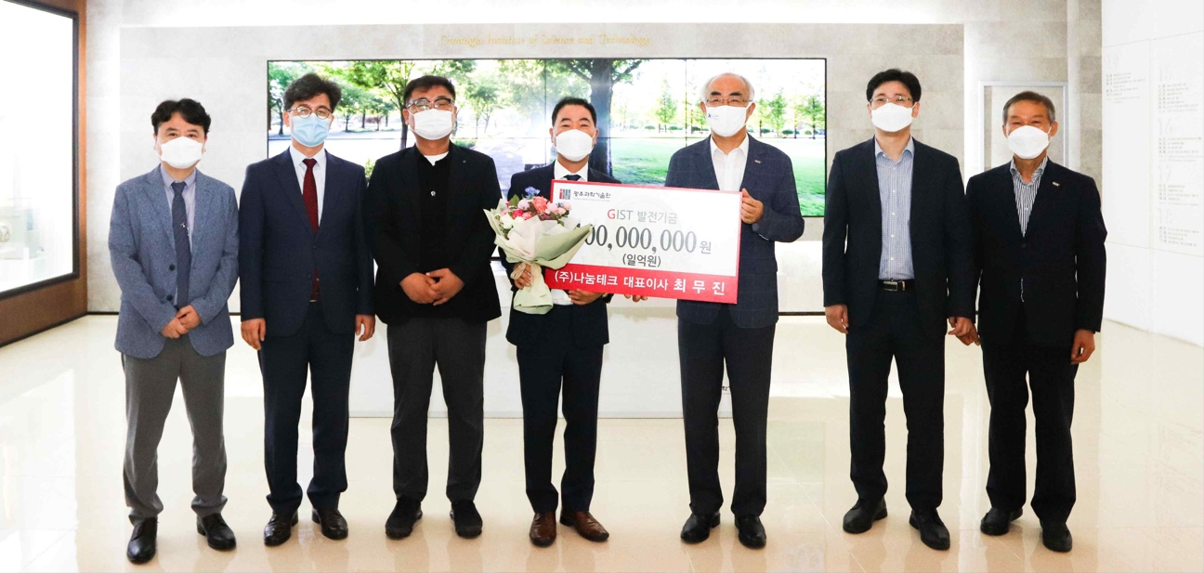

▲ Nanum Tech Co., Ltd., CEO Moo-jin Choi donates to the GIST Development Fund