

**Gwangju Institute of Science and Technology**

**Official Press Release (https://www.gist.ac.kr/)**

**Section of** Mi-Yeon Kim Nayeong Lee

**Public Affairs** Section Chief Senior Administrator

(+82) 62-715-2020 (+82) 62-715-2024

**Contact Person** Mi-na Choi, Administrator

**for this Article** GIST Academy

(+82) 62-715-2622

**Release Date** 208.09.05

**GIST GTMB invites Golden Equator, a Singaporean investment firm, for consultations and lectures**

□ GIST (President Seung Hyeon Moon) – GTMBA and Dean of International and Public Affairs Yong Chul Kim invited the Signaporean investment firm to provide consultations and lectures on September 4, 2018, which was attended by about 50 people.

° Golden Equator is Singapore's leading asset management company established in 2012 and has its own investment ecosystem that includes corporate clients, investments, and consulting. To successfully establish an AI-focused start-up town, GIST earlier this year signed an MoU to work with Golden Equator.

□ The lecture 'Southeast Asia: It's Time to Act' by Adam Flinter, a business consultant for Golden Equator, focused on Southeast Asia's start-up investment, funding, and market entry. The lecture introducted the business environment, advanced strategies, and specific success stories of the densely populated Southeast Asian market.

□ Corporate consulting for GIST GTMBA and the Climate Change Academy was conducted prior to the lecture. Two Golden Equator consultants were invited to participate in the company- And the direction of investment. Two experts from Golden Equator gave specific advice about strategies for overseas expansion and investment to the participants who had submitted their company information in advance.

□ Dean of International and Public Affairs Yong Chul Kim said, "Through this consultation and lecture, it is expected that CEOs in our region who participate in GIST GTMBA and the Climate Change Academy will understand the Southeast Asian market and investment environment and will help them prepare a preemptive response for global advancement."

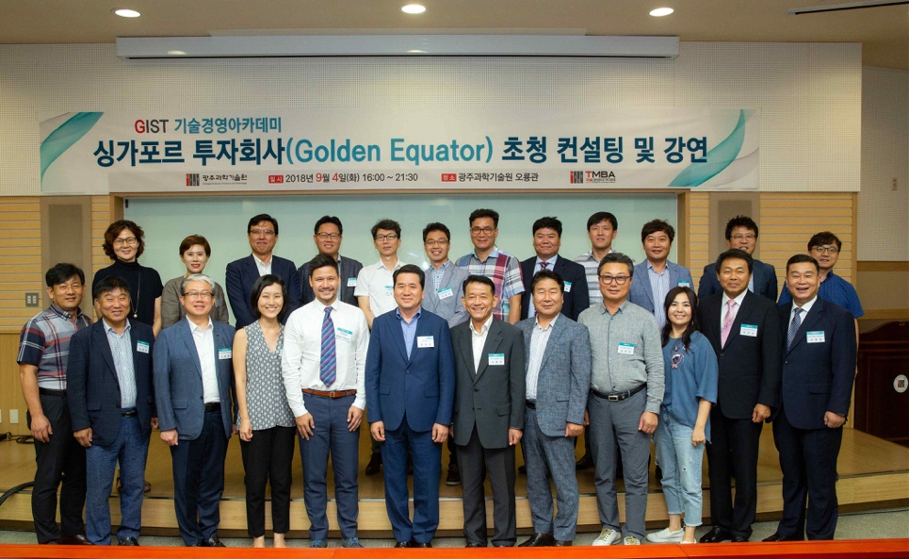

GIST GTMBA and Golden Equator consultants on September 4, 2018

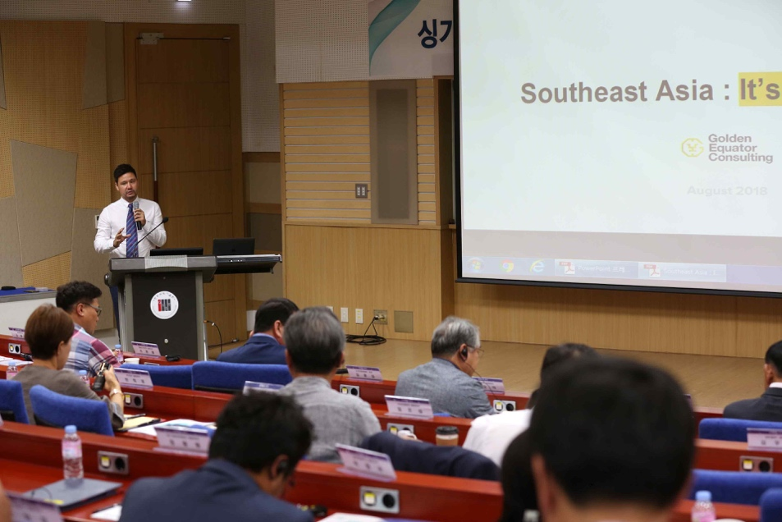

Golden Equator consultant Adam Flinter gives a lecture