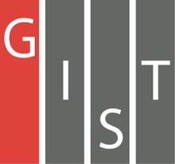

**Gwangju Institute of Science and Technology**

**Official Press Release (https://www.gist.ac.kr/)**

**Section of** Hyo Jung Kim Nayeong Lee

**Public Relations** Section Chief Senior Administrator

(+82) 62-715-2061 (+82) 62-715-2062

**Contact Person** Seung-soo Yoo, Administrator

**for this Article** Section of Public Affairs

(+82) 62-715-2025

**Release Date** 2020.03.26

**GIST and KAISt sign MoU for human resource development and international joint**

**research projects**

□ Gwangju Institute of Science and Technology (GIST, President Kiseon Kim) and Korea Advanced Institute of Science and Technology (KAIST, President Sung-Chul Shin) have signed a signed a memorandum of understanding (MoU0 to promote education and research in the field of artificial intelligence.

∘ To prevent the recent spread of COVID-19 infections, the MoU was signed at both institutions on March 25, 2020.

∘ The main contents of the agreement included ▲ education and personnel exchange in the field of artificial intelligence ▲ research and development and technology exchange in the field of artificial intelligence ▲ joint international cooperation in the field of artificial intelligence ▲ expanding performance in the field of artificial intelligence and fostering startups.

□ This agreement was carried out as part of the 'International Cooperation Project for the GIST and KAIST Graduate School of AI,' which will for the first time in Korea foster specialists and promote joint international AI research in the field of AI convergence by forming a global AI convergence network and by establishing a system for attracting human resources.

∘ In addition, GIST is pushing forward with joint research and collaboration in research and education with the Massachusetts Institute of Technology (MIT), which is conducting research on future new technologies by securing the global competitiveness of AI specialized universities.

□ GIST President Kiseon Kim said, "This agreement will secure global competitiveness and develop new technologies in the future through the re-development of AI-specific universities and expansion of AI research capabilities. In addition, we expect positive impact on revitalizing the local economy by creating and commercializing AI-centered start-up models that supports the education-research-startup ecosystem."

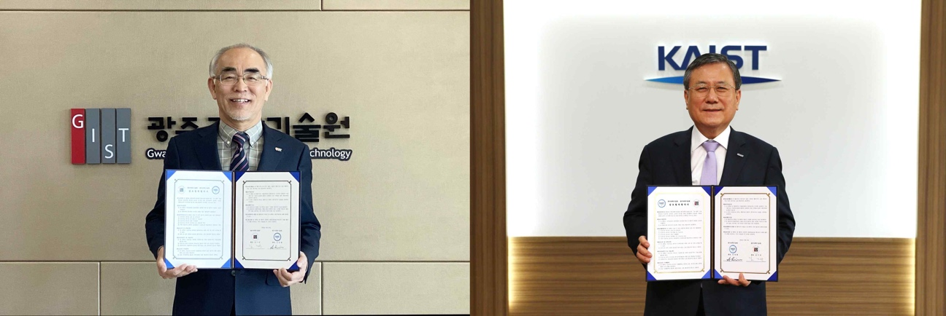

[Photo] (from the left) GIST President Kiseon Kim and KAIST President Sung-Chul Shin