

**Gwangju Institute of Science and Technology**

**Official Press Release (https://www.gist.ac.kr/)**

**Section of** Hyo Jung Kim Nayeong Lee

**Public Relations** Section Chief Senior Administrator

(+82) 62-715-2061 (+82) 62-715-2062

**Contact Person** Seung Su You, Administrator

**for this Article** Section of Public Affairs

062-715-2021

**Release Date** 2020.09.23

**Hong Growth Society donates 20 million won for student training and research development**

□ GIST (Gwangju Institute of Science and Technology, President Kiseon Kim) received a donation of 20 million won from the Hong Growth Society (Chairman Jang-hong Lee) to support scholarships and academic research.

∘ A total of 10 outstanding GIST students of will receive the scholarship, including five graduate students and five college students, and the research fund will be used to purchase equipment for the GIST Antiviral Research Center.

□ Chairman Jang-hong Lee said, "Believing in the infinite growth potential of GIST, I am very happy to contribute to help train science students for regional development. As I have high expectations for GIST, I am interested in supporting the students' growth and research development, so I hope that my sincerity will be appreciated by them."

∘ The Hong Growth Society was established in 1994 and has been providing scholarships and living expenses every year to middle and high school students in Gwangju. Starting this year, universities and graduate schools were also included, and GIST received donations in June.

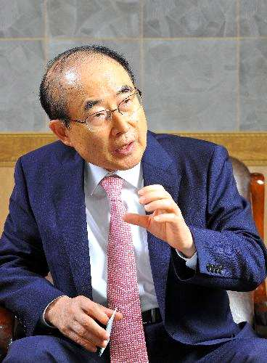

▲ Hong Growth Society Chairman Jang-hong Lee