

**Gwangju Institute of Science and Technology**

**Official Press Release (https://www.gist.ac.kr/)**

**Section of** Hyo Jung Kim Nayeong Lee

**Public Affairs** Section Chief Senior Administrator

(+82) 62-715-2061 (+82) 62-715-2062

**Contact Person** Yoo-mi Ahn, Administrator

**for this Article** International Environmental Research Institute

(+82) 62-715-3366

**Release Date** 2019.12.20

**GIST International Environmental Research Institute to conduct scientific and Hallyu activities in developing countries**

□ Gwangju Institute of Science and Technology (GIST, President Kiseon Kim) International Environmental Research Institute (IERI, Director Kyoung-Woong Kim) held the IERI Science Camp 2019 for five days starting on December 19 in Cambodia to educate rural Cambodian high school students about sustainable environmental issues in developing countries.

∘ This camp has been organized as part of the Korea-UNDP * project that the GIST International Environmental Research Institute has been carrying out since 2017. To highlight the importance of safe drinking water and hygiene, the program consists of interesting scientific experiments that demonstrates the chemical and electrical properties of water, including training on proper of hand washing techniques.

* Korea-UNDP is a joint project between the Ministry of Science and ICT, the United Nations Development Program, and the United Nations Office for South-South Cooperation with the aim of lowering the poverty level in countries by identifying and solving science, technology, and ICT related problems.

∘ The science camp not only tested the characteristics of water, such as electrical current and acidity measurements, but took the time to help the students understand and share the importance of water with interesting experiments, such as 'Secret Letter' and 'Playing Tricks with Pepper and Soap.'

□ International Environmental Research Institute Director Kyoung-Woong Kim (School of Earth Sciences and Environmental Engineering professor) said, "We hope that this science camp will provide an opportunity for students in rural Cambodia to develop their dreams by increasing their closeness to science. Additionally, in the future, we will we will continue our efforts in education and support for water quality hygiene with friendly on-site solutions to climate change issues."

□ GIST International Environmental Research Institute was established in 2001 with the aim of establishing a UN University Research Institute and has contributed to the improvement of the international environment by building cooperation in the climate technology field, by developing science and technology, and by supporting the development of technologies for coping with climate change at home and abroad.

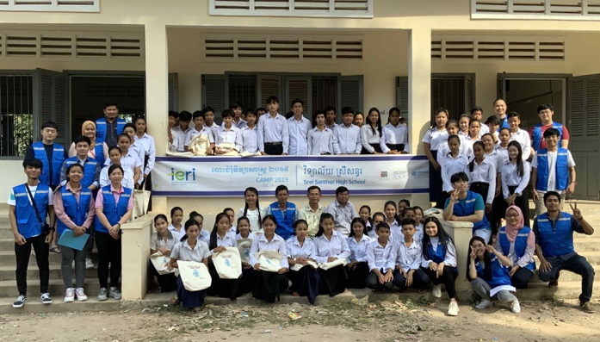

▲ [Photo 1] Group photo of GIST International Environmental

Research Institute members and participating students

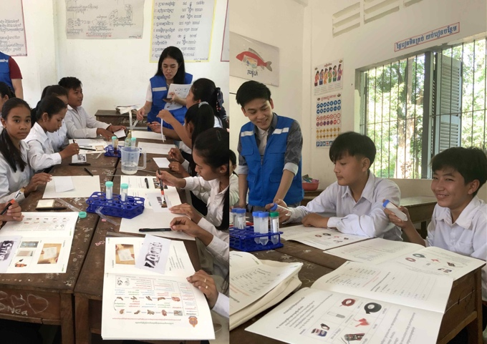

▲ [Photo 2] Participating students conducting scientific

experiments under the guidance of GIST members