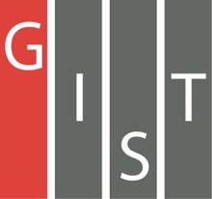

**Gwangju Institute of Science and Technology**

**Official Press Release (https://www.gist.ac.kr/)**

**Section of** Hyo Jung Kim Nayeong Lee

**Public Affairs** Section Chief Senior Administrator

(+82) 62-715-2061 (+82) 62-715-2062

**Contact Person** Joon-ho Song, Administrator

**for this Article** Section of Research Strategy

(+82) 62-715-5213

**Release Date** 2019.11.07

**GIST Research Institute (GRI) held a public hearing regarding national large-scale R&D bidding strategies**

□ GIST (President Kiseon Kim) Research Institute (GRI, Director In S. Kim) held a public hearing regarding national large-scale R&D bidding strategies to induce effective participation of R & D projects at the community and national level.

∘ This public hearing was carried out with the aim of enhancing the practicality and completeness of national large R&D project planning through listening to outside experts and discussion with researchers, while presenting a total of 16 research projects including 5 basic programs and 11 development programs of GIST professors and researchers.

□ The two-day event was held on November 6 and 7, 2019, at Oryong Hall with a total of 100 people including GIST President Kiseon Kim, Vice President Jong-In Song, and GIST Research Institute Director In S. Kim as well as domestic planning and policy advisors.

□ GIST President Kiseon Kim said, "We hope that this hearing will greatly contribute to GIST's research and planning leadership for the local community and region. Furthermore, we hope that GIST will become a new venue for joint research cooperation between the industry and the government by proposing large-scale national research projects to the Gwangju and the government."

∘ GRI Director In S. Kim presided over the public hearing and said, "I hope this event will be an opportunity to reinforce the planning function of large-scale research projects, which is a new challenge at the GIST level, and to induce effective participation of R&D projects at the community and national level."

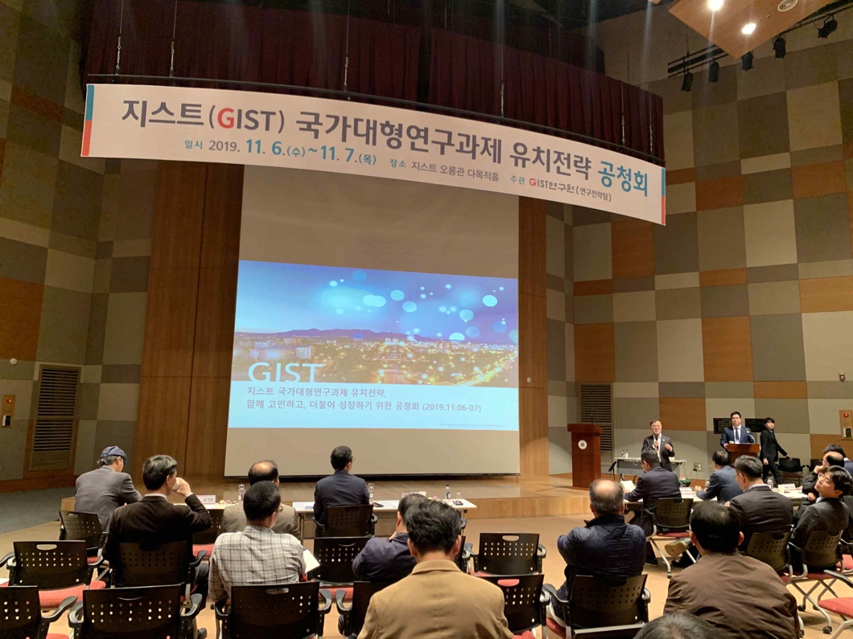

▲ Public hearing for attracting national large-scale R&D projects to GIST