

**Gwangju Institute of Science and Technology**

**Official Press Release (https://www.gist.ac.kr/)**

**Section of** Hyo Jung Kim Nayeong Lee

**Public Affairs** Section Chief Senior Administrator

(+82) 62-715-2061 (+82) 62-715-2062

**Contact Person** Yeo-jin Jung, Administrator

**for this Article** Advanced Photonics Research Institute

(+82) 62-715-3416

**Release Date** 2019.07.08

**Advanced Photonics Research Institute hosts Summer School for Laser and Laser Applications (SSOLLA 2019)**

□ GIST (President Kiseon Kim) Advanced Photonics Research Institute (APRI, Director Hyyong Suk) invited students and researchers from all over the world to participate in the Summer School for Laser and Laser Applications (SSOLLA 2019) from July 8 to 12, 2019, which ended successfully.

∘ This event will be attended by 17 students and researchers from 10 countries, including Japan and the Czech Republic, which are advanced countries in the field of laser, as well as GIST professors and APRI researchers.

∘ GIST Professors and APRI researchers plan to teach participants about optics, such as special optical fiber design and application, microprocessors using lasers, bio-optical imaging, femtosecond (1/1,000th of a second) laser spectroscopy, integrated optics, terahertz (THz: high frequency photonics that vibrates rapidly one trillion times a second) photonics, and will conduct various optical experiments.

□ The GIST Advanced Photonics Research Institute (APRI) is the only specialized photonics research institute in Korea and has developed the world's first laser of 20 femtoseconds/4.2 peta watts since its establishment in 2001. APRI is a leader in academic-industrial cooperation by transferring special optical fiber manufacturing technology to large Korean companies.

□ APRI Director Hyyong Suk said, "Since 2010, GIST has held an annual SSOLLA event to train 182 graduate students, researchers, and others around the world. We have been been strengthening its status by promoting international cooperation through exchanges with overseas researchers in the laser optics fields. In the future, we plan to contribute to the development of domestic optical technology through close cooperation with universities in Europe, such as Germany and Switzerland, as well as with the Lawrence Berkeley National Laboratory (LBNL) and the Stanford Linear Accelerator Center (SLAC)."

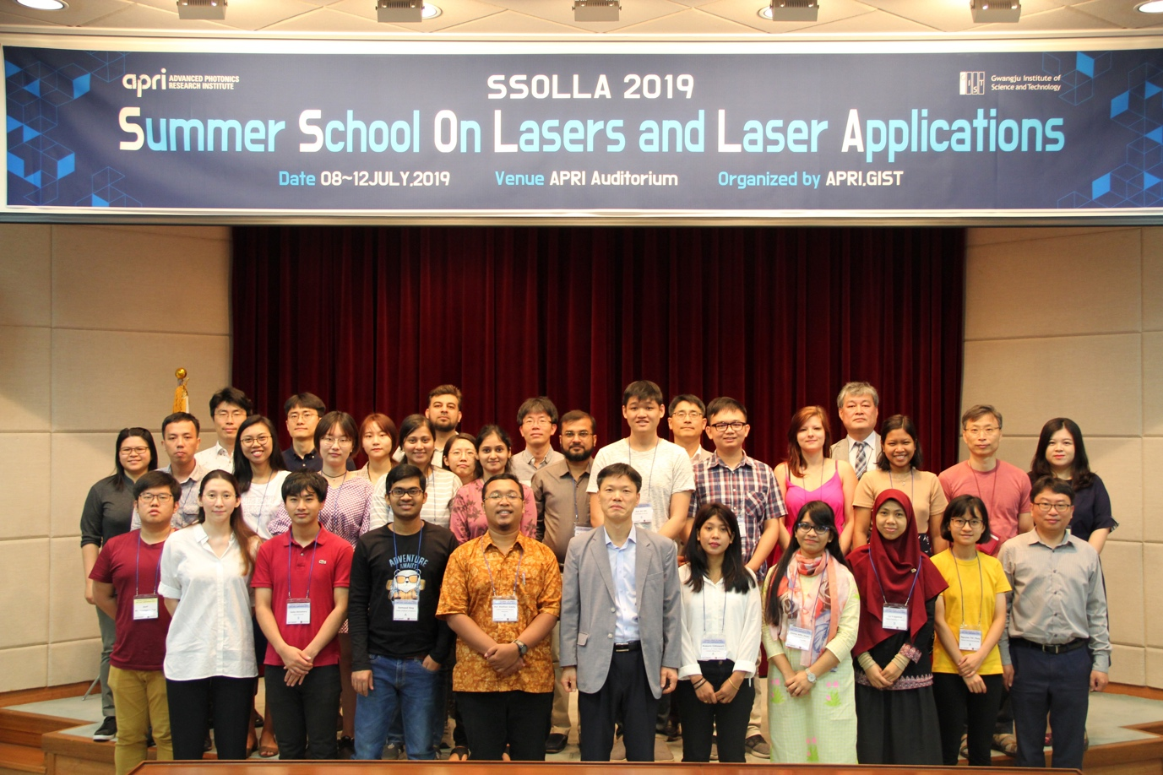

▲ GIST APRI SSOLLA 2019 commemorative opening ceremony photo