

**Gwangju Institute of Science and Technology**

**Official Press Release (https://www.gist.ac.kr/)**

**Section of** Hyo Jung Kim Nayeong Lee

**Public Relations** Section Chief Senior Administrator

(+82) 62-715-2061 (+82) 62-715-2062

**Contact Person** Hyun-jin Kim, Administrator

**for this Article** Section of Undergraduate Admissions

062-715-2956

**Release Date** 2020.09.22

**GIST conducts online admissions interviews for students entering the 2021 academic school year**

□ As a science and technology specialized university that celebrates its 27th anniversary this year, GIST (Gwangju Institute of Science and Technology, President Kiseon Kim) will begin it early admission process for the 2021 academic school year, which will be its 12th class of new freshmen.

∘ GIST College plans to select a total of 180 students in the early admission process with about 115 students chosen through general admission, 40 students by screening the recommendations of high school principals, 15 students through a rotational process, and 10 students will be selected by screening for special talents, which is based on practical skills.

□ Because the health and safety of applicants are a top priority due to the COVID-19 situation, GIST will change the interview evaluation process for 2021 so that it will be a 'non-face-to-face (online) evaluation.' Interviewees will not visit GIST in person but will be interviewed via online video in independent spaces such as their homes or dormitories.

∘ A large number of interviewers will conduct interviews with 10 to 20 minutes given to each applicant, and, in the case of students requiring comprehensive screening, their aptitude and major mathematical skills will be determined by submitted documents such as school records and cover letters. What is significantly different from previous years is that they will not solve math and science problems. In addition, for students selected by screening for special talents, which is a practical skill-oriented screening, the student's special talent, personality, aptitude, and giftedness are evaluated based on the school records, self-introductions, and other relevant evidence.

□ Office of Admissions Dean Keun-Young Kim (Department of Physics and Photon Science professor) said, "The reason for the switching to online interviews is for the health and safety of the applicants, and this is intended to prevent candidates from being marginalized due to COVID-19 by allowing those who are self-quarantined or confirmed cases an opportunity to be interviewed. As this is the first time for online admissions interviews, a mock interview will be conducted so that the applicants can experience the actual process in advance to help them prepare for the interview. During this mock interview, we will check the applicant's PC video and audio while guiding them through the online interview process."

□ The application period for GIST College's 2021 academic school year is from 9 a.m. on September 23, 2020, to 6 p.m. on September 28, 2020, and applications will be accepted online (https://www.gist.ac.kr/uadm/). The announcement of successful candidates is scheduled for December 11, and the announcement of additional successful candidates will be made from December 31, 2020, to January 4, 2021.

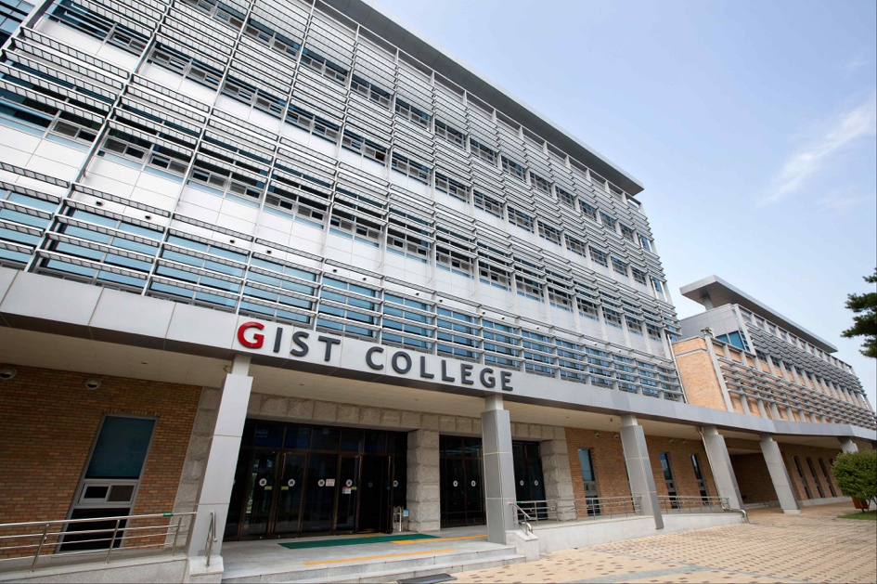

▲ Photo 1. GIST College Building A

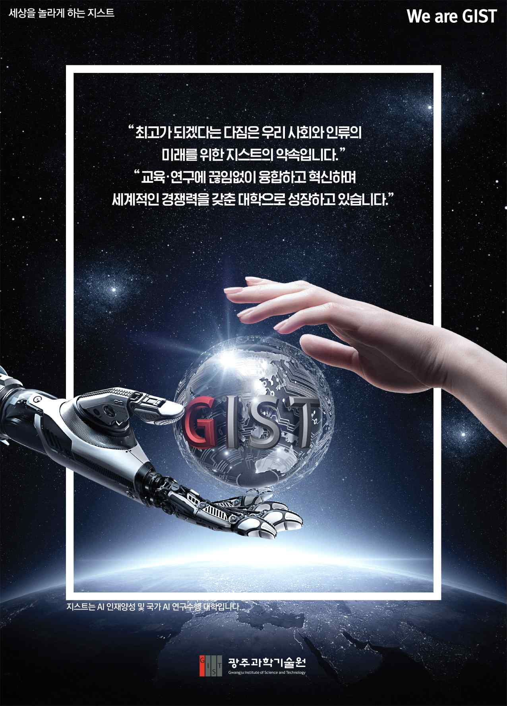

▲ Photo 2. GIST Promotion Poster