

**Gwangju Institute of Science and Technology**

**Official Press Release (https://www.gist.ac.kr/)**

**Section of** Hyo Jung Kim Nayeong Lee

**Public Relations** Section Chief Senior Administrator

(+82) 62-715-2061 (+82) 62-715-2062

**Contact Person** Moon-seop Yoon, Administrator

**for this Article** Section of Public Affairs

+(82) 62-715-2021

**Release Date** 2020.06.30

**GIST hosts Lotte Scholarship Foundation-GIST Global Talent Scholarship Award Ceremony**

□ GIST (Gwangju Institute of Science and Technology, President Kiseon Kim) held the the Lotte Scholarship Foundation-Gist Global Talent Scholarship Ceremony on June 29, 2020. On this day, Chairman of the Lotte Scholarship Foundation, Sung-Kwan Huh (the 4th President of GIST), visited GIST and delivered the scholarship certificate to 14 foreign students who were selected as scholarship students this year.

□ GIST has been providing scholarships from the Lotte Scholarship Foundation for two consecutive years since 2019 to outstanding overseas students who enter GIST for the purpose of discovering science and technology research personnel to secure competitiveness in science and technology by strengthening global capabilities and to enhance basic research. So far, the Lotte Scholarship Foundation has donated 183,300,000 won to the scholarship fund, which has supported a total of 31 students.

∘ The Lotte Scholarship Foundation was established in 1983 with the private property of honorary chairman Keung-ho Shin, the founder of Lotte Group, and has steadily supported scholarships, academic promotion, and welfare projects. In particular, more than 45,600 students were given 67.5 billion won in scholarships and 50 billion won in welfare projects.

□ On the same day, a plaque of appreciation was delivered to Chairman Huh Sung-kwan, and the ceremony was attended by foreign students and professors of GIST who were selected as scholarship students. Chairman Sung-Kwan Huh said, "As a person who served as GIST's president, I am deeply moved. Please do your best to grow GIST as a representative institution for nurturing global talent."

∘ Among the attendees, Muhammad Awais, a Ph.D. student in the School of Electrical Engineering and Computer Science, said, “I want to thank the Lotte Scholarship Foundation for helping us to concentrate on our studies, and we will return your favor by growing up as a global leader in the future."

□ In addition, the award ceremony was carried out safely by following the guidelines for preventing the spread of COVID-19.

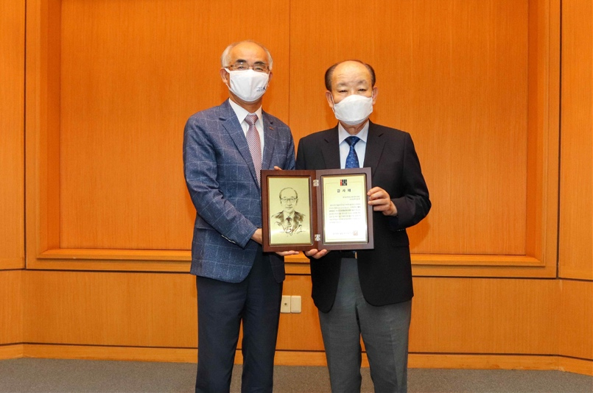

[Photo 1] Appreciation plaque delivered (GIST President Kiseon Kim

and Lotte Scholarship Foundation Chairman Sung-Kwan Huh)

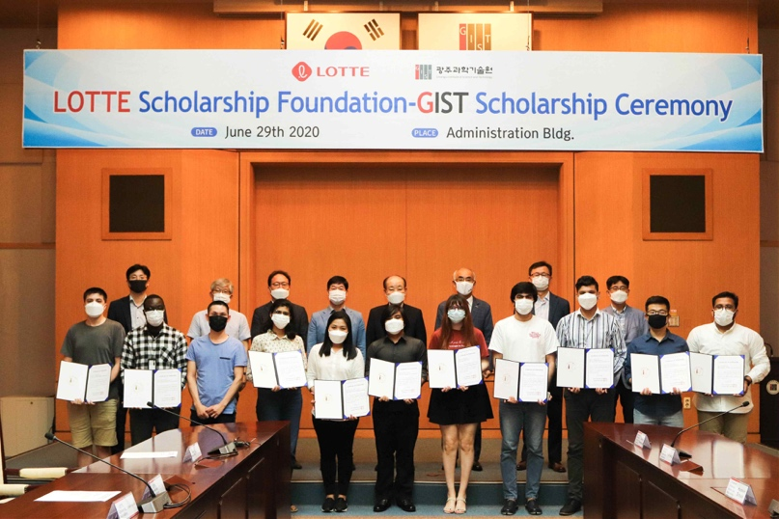

[Photo 2] Lotte Scholarship Foundation

group photo with GIST Global Scholars