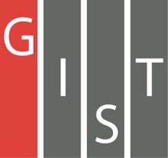

**Gwangju Institute of Science and Technology**

**Official Press Release (https://www.gist.ac.kr/)**

**Section of** Hyo Jung Kim Nayeong Lee

**Public Affairs** Section Chief Senior Administrator

(+82) 62-715-2061 (+82) 62-715-2062

**Contact Person** Chang-seok Kim, Senior Researcher

**for this Article** Aging-Friendly Industry Support Center

(+82) 70-7710-4901

**Release Date** 2019.09.18

**"Gwangju Regional Networking Day for Innovative Jobs" held to increase jobs tailored to local industries**

□ GIST (President Kiseon Kim) – The Gwangju Regional Development Committee, the Korea Association for Photonics Industry Development, and the Regional Employment Policy Institute have gathered together to address the crisis in Gwangju's regional industries, the shortage of professionals, miss matched jobs, and creating good jobs.

∘ The "2019 Gwangju Regional Networking Day for Innovative Jobs" was held on September 18, 2019, at the Kim Dae-jung Convention Center and included the participation of eight regional innovative projects to increase the employment of skilled jobs for the leading industries in the region.

□ Based on the recruitment plans of excellent companies in the region that was collected by the Gwangju Design Center, such as the Korea Association for Photonics Industry Development and Gwangju Techno Park, the event helped to match local specialists with customized job matching between local college job centers and government agencies.

∘ In addition, senior technical professionals who were discovered and trained by GIST participated to provide 1 to 1 mentoring for local SMEs and young people to help them solve problems such as operation, technology, patents, and market development of local SMEs and improve job awareness of local youths. In addition, various events were held, such as job counseling and profile pictures.

□ Aging-Friendly Industry Support Center Director Sung-jo Kwak said, "We will take the lead in enabling local high-tech professionals to continue to work to strengthen the competitiveness of local companies and to enhance the capabilities of young people.

∘ Hyun-chul Kang of the Gwangju Employment and Labor Office said, "We hope this event will be a great opportunity to recruit talented people for local industries, resolve technical difficulties, and help young people find to jobs at good companies. We will continue to support central government to create innovative jobs in the region."

□ The Aging-Friendly Industry Support Center opened in 2013 with the support of Gwangju City and the Ministry of Industry to promote the growth of age-related industries and has been implementing projects to develop technologies related to aging, training specialists, operating experience centers, and promoting the establishment of 4th Industrial Revolution technologies such as AI and Big Data.

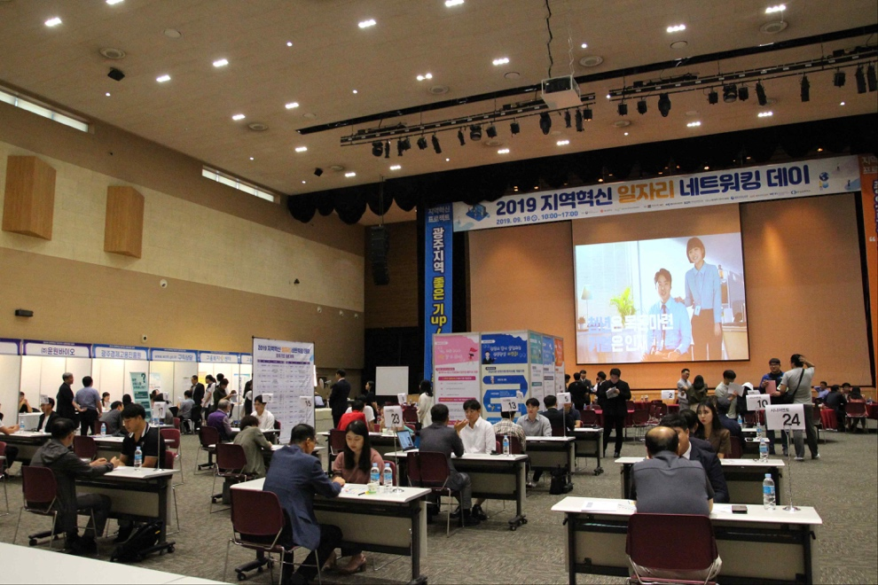

Photo 1: 2019 Gwangju Regional Networking Day for Innovative Jobs

with seniors mentoring young people

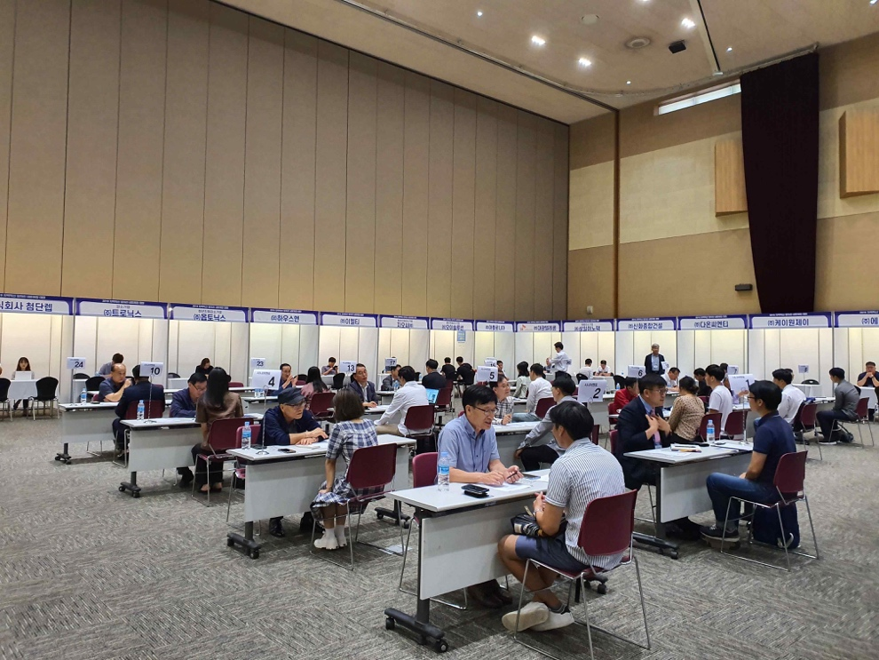

Photo 2: 2019 Gwangju Regional Networking Day for Innovative Jobs

recruitment by leading companies