Jeong Won Kim

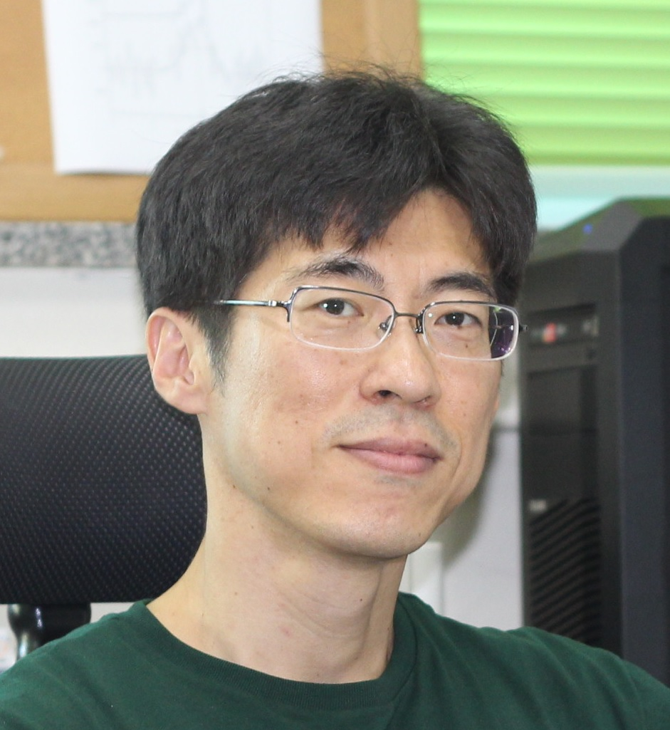
Head of Center for Nanocharacterization
Korea Research Institute of Standards and Science (KRISS)
267 Gajeong-Ro, Yuseong
Daejeon, 34113, KOREA
TEL: +82–42–868–5761
E-mail: jeongwonk@kriss.re.kr
Home Page: http://pes.kriss.re.kr/

Education:
1993–1997 Ph.D. KAIST (S. Kim)
1991–1993 M.S. KAIST (S. Kim)
1987–1991 B.S. KAIST, Daejeon
Professional Career:
2012 Visiting scholar at Univ. Texas-Austin (X.-Y. Zhu)
2009–present Adjunct professor at University of Science and Technology (UST)
2004–present Staff Scientist, KRISS
2002–2004 Postdoctoral Fellow, Fritz-Haber-Institut der MPG (K. Horn)
2000–2002 Research Associate, Yonsei Univ. (H.W. Yeom)
1997–2000 Senior Engineer, LG Semicon (former SK Hynix)
Professional Activities:
2006–present Member, Korean Physical Society
2005–present Member, Korean Vacuum Society
2006–present Member, Korean Chemical Society

Research Interests:
1. Electronic Structure of Organic Semiconductor Interfaces (OLEDs, OTFTs, Photovoltaics)
2. Ultrafast Charge Carrier Dynamics at Surface and Interface
3. Characterization of Nanomaterial Surfaces

Selected Publications (Total: 101):
1. Heeseon Lim, Hyuksang Kwon, Sang Kyu Kim, and Jeong Won Kim,“Delayed Triplet-State Formation through Hybrid Charge Transfer Exciton at Copper Phthalocyanine/GaAs Heterojunction”, J. Phys. Chem. Lett. 8, 4763 (2017).
2. Hyuksang Kwon, Sung Won Seo, Tae Gun Kim, Eun Seong Lee, Phung Thi Lanh, Sena Yang, Sunmin Ryu, and Jeong Won Kim,“Ultrathin and Flat Layer Black Phosphorus Fabricated by Reactive Oxygen and Water Rinse”, ACS Nano, 10, 8723 (2016).
3. Myeong-Ho Kim, Young-Ahn Lee, Jinseo Kim, Jucheol Park, Seungbae Ahn, Ki-Joon Jeon, Jeong Won Kim, Duck-Kyun Choi, and Hyungtak Seo, “Photochemical Hydrogen Doping Induced Embedded Two-Dimensional Metallic Channel Formation in InGaZnO at Room Temperature”, ACS Nano 9, 9964 (2015).
4. Jeong Won Kim, Heungman Park, Xiaoyang Zhu, "Charge Transport and Separation Dynamics at the C₆₀/GaAs(001) Interface", J. Phys. Chem. C 118, 2987 (2014).

