Professor Chul-Han Song of the School of Environment and Energy Engineering elected as the first chairman of the GIST Council

- October 7, the inauguration ceremony of the council and the first regular meeting... 12 council members in total, including 5 faculty members, 2 researchers, 2 staff members, and 2 students, 11 internal council members and 1 external council member

- Inaugural Chairman Chul-Han Song, "We will strive to become a council that gathers diverse voices and wisdom within the school and contributes to the welfare of members and the development of the institution."

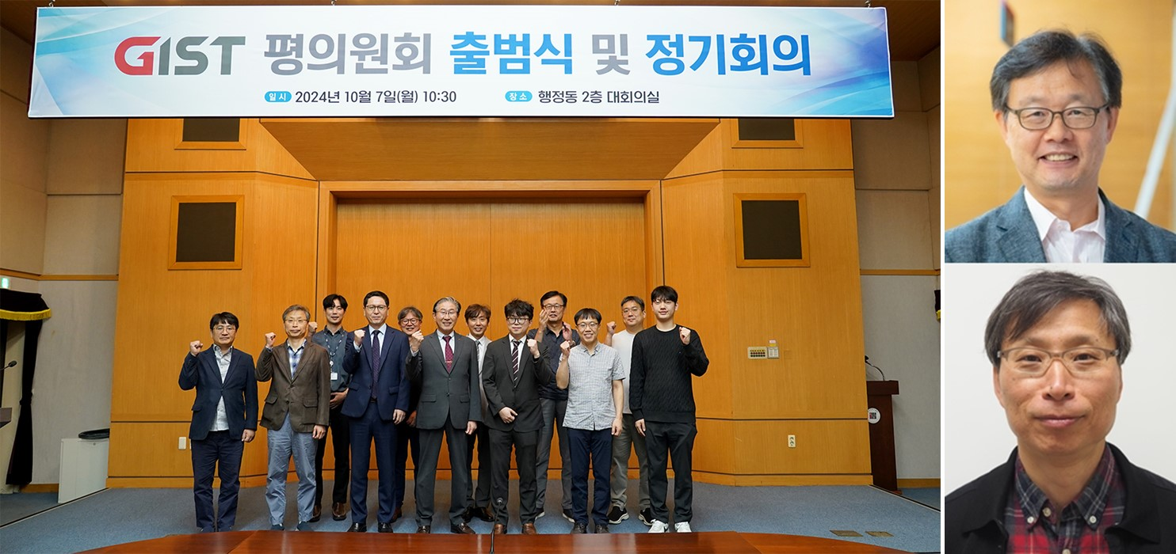▲ GIST is taking a commemorative photo after holding the inauguration ceremony and the first regular meeting of the council in the conference room on the 2nd floor of the administrative building on Monday, October 7. (Right photo) Professor Chul-Han Song of the School of Environment and Energy Engineering (top), who was elected as the first chairman and vice chairman of the council, and Senior Researcher Chul-Sik Kee of the Advanced Photonics Research Institute (bottom)

Professor Chul-Han Song (59) of the School of Environment and Energy Engineering was elected as the first chairman of the GIST Council, a deliberative and advisory body in which all members of the Gwangju Institute of Science and Technology (GIST, President Kichul Lim) participate, including faculty, researchers, staff, and students.

The GIST Council held its first regular meeting on the morning of Monday, October 7th in the conference room on the second floor of the administrative building and passed the agenda to elect Professor Song as the first chairman.

Professor Song, who has been working on fostering talent and conducting research in the climate and atmosphere field for 20 years since joining GIST in 2004, served as the director of the Earth and Environmental Modeling Center, head of the BK21 PLUS Environmental Engineering Convergence Talent Training Project, and member of the National Climate and Environment Council. He is currently the director of the Korean Air Quality Forecasting Model Development Project Team (National Fine Dust Strategy Project).

Professor Song said, "The GIST Council should be a democratic communication venue where representatives of all the constituent units of the school gather to talk to each other politely and without formality, and exchange constructive opinions based on reason and logic. We will strive to become a council that gathers diverse voices and wisdom within the school and contributes to the welfare of its members and the development of the institution."

Along with this, Senior Researcher Chul-Sik Kee of the Advanced Photonics Research Institute, who is the representative council member of the research institute, was elected as the first vice-chairman of the GIST Council.

Senior Researcher Chul-Sik Kee, who also participated in the preparatory committee for the launch of the Council, said, "I will strive to make the Council a body where members can freely express their opinions and convey those opinions to the management, so that we can all work together for the development of the school."

Meanwhile, the GIST Council held an inauguration ceremony prior to the regular meeting that day, attended by President Kichul Lim, Vice President for Academic Affairs Sang-Don Kim, Planning Dean Hisam Kim, and nine council members.

The GIST Council consists of 12 members, including 11 internal council members (5 faculty members, 2 researchers, 2 staff members, 2 students) and 1 external council member.

According to the regulations, the Council deliberates on ▴ matters related to the mid- to long-term development plan, ▴ important matters related to the welfare of faculty members, researchers, staff members, and students, ▴ other matters that the president, the chair, or more than one-third of the council members in attendance deem important for the operation of the school and request deliberation, and ▴ plays an advisory role on important matters related to the welfare of faculty members, researchers, staff members, and students.

The Election Management Committee of the Council elected nine internal council members through the faculty, researcher, and staff council member elections from September 19 to 23, and Professor Seok-Young Woong (Department of Bioengineering) of Chonnam National University, who graduated from the first GIST undergraduate program and received his bachelor’s, master’s, and doctoral degrees from GIST, was appointed as an external council member appointed by the president.

In the case of students, Tae-il Ha (AI Graduate School), the president of the graduate school student council, and Tae-gyu Yang (School of Materials Science and Engineering), the chairman of the undergraduate program emergency response committee, were appointed as council members as representatives of student groups.

President Kichul Lim said during the congratulatory speech at the inauguration ceremony, "The power to harmoniously integrate diverse opinions is the driving force behind GIST's development.

I hope that the devotion and efforts of the council will be a great help in solving the many challenges we will face in the future, and I will actively support the council so that it can operate without a hitch."



