The 19th Gyeongam Bio Youth Camp held at GIST

- A famous Korean biologist gave a lecture to about 100 science aspiring high school students
- Held all over the country, including Seoul, Daejeon, Gwangju, Daegu, and Busan... Gwangju held at GIST

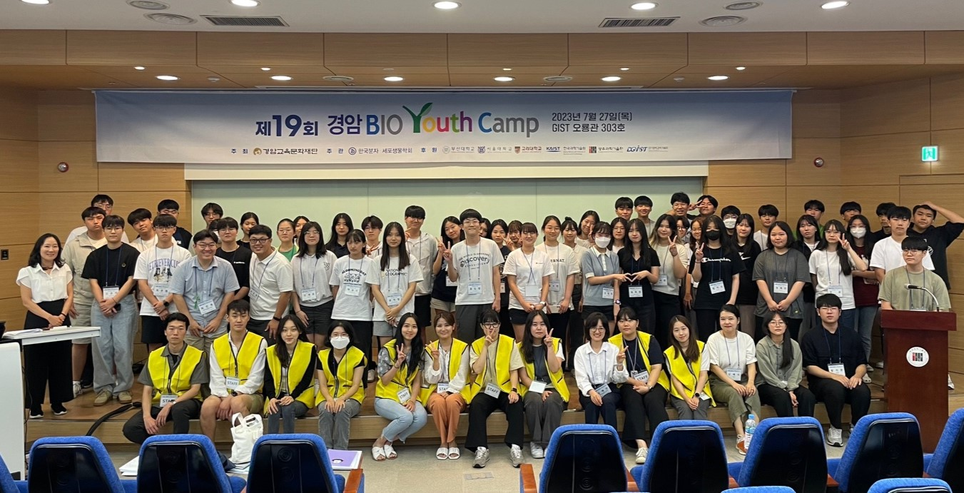▲ Group photo of the 19th Gyeongam Bio Youth Camp participants

At GIST (Gwangju Institute of Science and Technology, President Kichul Lim), the 19th Gyeongam Bio Youth Camp was held with about 100 high school students aspiring to become biologists in attendance.

This event invites renowned domestic scientists to deliver the latest research achievements in the field of life science to high school students. It has been held since 2005, hosted by the Gyeongam Education and Culture Foundation, supervised by the Korean Society for Molecular and Cellular Biology, and sponsored by six universities including GIST, KAIST, and DGIST.

This year, it was held in five cities including Gwangju, Seoul, Daejeon, Daegu, and Busan on July 26 and 27, and in Gwangju, it was held on the 27th at GIST Oryonggwan.

The event was followed by various lectures and Q&A, starting with the opening company of GIST Life Sciences Professor Jang-Soo Chun, winner of the 10th Gyeongam Academic Award, and congratulatory remarks by GIST Vice President Kwanghee Lee, winner of the 6th Gyeongam Academic Award.

The lectures included, ▴ Dr. Dae-hee Lee of the Korea Research Institute of Bioscience and Biotechnology, “Can living organisms be created just as Lego blocks are stacked?” ▴ Professor Jaeik Kim of UNIST, “Degenerative Brain Diseases: Why It's Difficult to Develop a Treatment” ▴ Chosun University College of Pharmacy Professor Heon-Woo Lee, “Catching Diseases by Catching Blood Vessels” ▴ Yonsei University Professor Ji-won Oh’s “How does the human lens become the whole body? (Birth of life found in a corpse)”.

Dr. Lee Dae-hee, who participated as the first lecturer, gave a lecture on “Synthetic Biology” and received a great response. In synthetic biology, microbial life is reconstructed through DNA synthesis and chemicals needed by mankind, such as 'spider silk' and 'bio-fuel', are produced in living organisms. Several companies in developed countries have already utilized this. It aroused interest by saying that it was creating high added value.

Also, Professor Ji-won Oh drew attention by mentioning “the birth of life found in the corpse”. She introduced a technique to trace the differentiation process from embryonic cells to organ development by autopsying unfrozen corpses, and explained in detail the process of studying how the human body is made using the latest techniques.

In his congratulatory speech, Vice President Kwanghee Lee said, "As a recipient of the Gyeongam Academic Prize, called the Nobel Prize in Korea, I feel very honored by participating in the Gyeongam Bio Youth Camp. With this camp as an opportunity, we hope that students will grow into talented people who will lead the nation's science and technology and become the first Korean to receive the Nobel Prize in Physiology or Medicine."

On the other hand, Gyeongam Bio Youth Camp is responding to the dynamic global trend in the field of life science based on active support from the Gyeongam Education and Culture Foundation. Since 2016, camps have been held in various parts of the country so that more teenagers can become interested in life science.



