GIST celebrates its 30th anniversary with an abundance of cultural events including lectures, music, exhibitions, and plays with local residents

- Ajou University Professor Guk-jong Lee’s invited lecture ‘The Beginning of the End’ / Classical concert ‘Healing Concert’ / Artist Jo-heum Lee’s invitation exhibition <Universe> / Student theater club ‘Physicists’, etc.

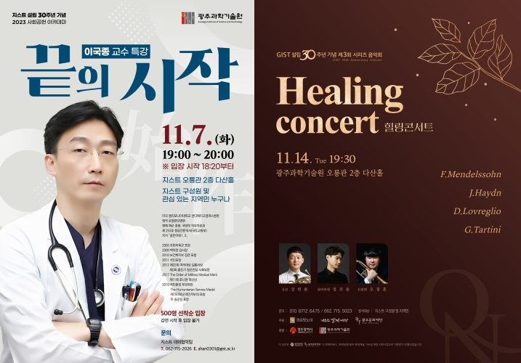▲ Poster for GIST’s 30th anniversary special lecture ‘The Beginning of the End’ by Professor Guk-jong Lee (left) and series concert ‘Healing Concert’ poster (right)

In celebration of its 30th anniversary, the Gwangju Institute of Science and Technology (GIST, President Kichul Lim) announced that it will hold useful cultural events in November that local residents can enjoy, such as lectures at the Social Contribution Academy and classical music concerts.

On Tuesday, November 7, a lecture at the Social Contribution Academy will be held by inviting Ajou University Professor Guk-jong Lee, the nation's top authority in the field of severe trauma treatment.Professor Lee became widely known to the public by treating Captain Seok Hae-kyun, who was seriously injured during the rescue operation of the Jewelry, which was kidnapped by Somali pirates in 2011, and a soldier who defected in Panmunjeom in 2017.

Under the theme of ‘The Beginning of the End,’ Professor Lee plans to communicate with the audience by introducing his vivid experiences in the medical field as a surgeon for the past 30 years and introducing advanced emergency medical systems overseas.

Anyone can listen to Professor Guk-jong Lee's public lecture, which will be held at 7 PM on the 7th (Tuesday) in Dasan Hall (535 seats) on the 2nd floor of GIST's Oryong Hall. Admission is available on a first-come, first-served basis starting 40 minutes before the lecture begins.

The final performance of the ‘Classical Series Concert’ with local residents will be held on Tuesday, November 14th.

GIST planned a total of three performances with the string quartet ‘QUARTET NEU’, starting with ‘Green Land’ on August 29th. On September 15th, the second performance ‘Starlight concert’ was held and received a lot of interest and response from local residents.

The third and final performance, ‘Healing concert’, will be held at GIST Oryong Hall Dasan Hall on the 14th (Tuesday) from 7:30 PM with the theme of ‘Recovery and Comfort in Daily Life’, which will present beautiful classical melodies on a deepening autumn night.

This performance will consist of familiar and comfortable repertoire with the participation of first violinist Lee Jun-seong, second violinist Lee Joon, cello Kim Min-su, and viola Yang Shin-ae: ▴ the first movement of Mendelssohn’s String Quartet No. 2, Op. 13 is the first piece ▴ Haydn Horn Concerto No. 2 ▴ Excerpt from Verdi’s La Traviata by composer Donato Robre Glio ▴ Giuseppe Tartini’s Trumpet Concerto ▴ 4p to the 4th movement of Mendelssohn’s String Quartet No. 2, Op. 13.

In addition, the artist Joheum Lee's invitation exhibition <Universe> will be held at the Oryong Art Hall (GIST Oryong Hall 1st and 2nd floors) until December 27 (Wednesday). On November 24th (Friday) and 25th (Saturday), the 10th anniversary performance ‘Physicists’ of GIST student theater club ‘Jidae-ro’ will be held at the CT Art Hall in GIST Administrative Building and awaits the public’s viewing.

President Kichul Lim said, "In order to repay the interest and love shown to GIST over the years, we organized a series of cultural events for the local community to enjoy together. We would like to express our gratitude and appreciation to all those who have been involved in the development of GIST, and we will strive for the next 30 years to contribute to the revitalization of the local economy and the development of national science and technology."



