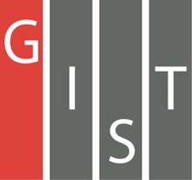

**Gwangju Institute of Science and Technology**

**Official Press Release (https://www.gist.ac.kr/)**

**Section of** Hyo Jung Kim Nayeong Lee

**Public Affairs** Section Chief Senior Administrator

(+82) 62-715-2061 (+82) 62-715-2062

**Contact Person** Tae-wook Kim, Administrator

**for this Article** Korea Culture Technology Institute

(+82) 62-715-4930

**Release Date** 2020.02.27

**GIST Korea Culture Technology Institute signs business agreement with the Gwangju Community Rehabilitation Center**

□ Gwangju Institute of Science and Technology (GIST, President Kiseon Kim) Korea Culture Technology Institute (Director Moongu Jeon) signed a business agreement with the Gwangju Community Rehabilitation Center (Director Mi-ran Kim) for the research and development of culture technology (CT) to ensure the right of hearing impaired individuals to enjoy cultural life.

∘ Technology for converting sound (voice) into text (subtitles) is already commercially available for the hearing impaired. However, as there are no technologies for converting Korean language, which is the first language of the hearing impaired Koreans, the agreement is meant to improve upon this. In particular, developing technology that translates exhibition commentaries and texts into Korean language is significant in that it is the first attempt not only for the hearing impaired in Gwangju but also for 300,000 deaf people across the country.

□ In making the agreement, Director Moongu Jeon said, "To maintain the cultural life of the deaf people who use Korean as their first language, the government will provide universal service so that anyone can enjoy culture by developing technology to convert exhibition commentary (audio-guide) announcements of major cultural infrastructure such as museums, art galleries, and exhibition facilities into 'texts' and 'Korean sign language animations.'"

□ Gwangju Community Rehabilitation Center Director Mi-ran Kim director expressed her support by saying, "This research project will be of great help for the enjoyment of cultural facilities for the hearing impaired."

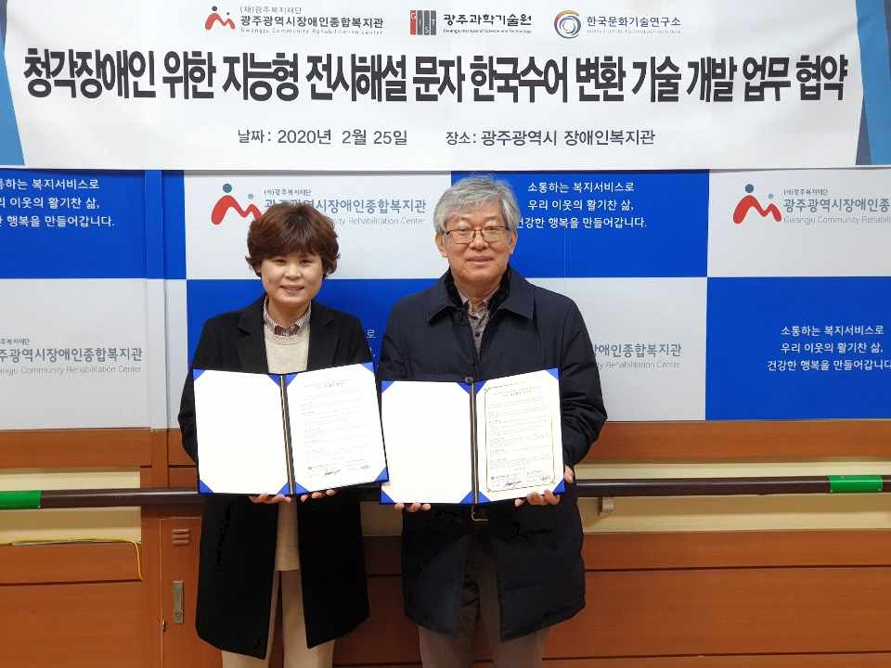

▲ GIST Korea Culture Technology Institute Director Moongu Jeon (right) and Gwangju Community Rehabilitation Center Director Mi-ran Kim at the agreement ceremony