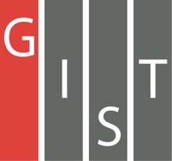

**Gwangju Institute of Science and Technology**

**Official Press Release (https://www.gist.ac.kr/)**

**Section of** Hyo Jung Kim Nayeong Lee

**Public Relations** Section Chief Senior Administrator

(+82) 62-715-2061 (+82) 62-715-2062

**Contact Person** Tae-wook Kim, Administrator

**for this Article** Korea Culture Technology Institute

062-715-4930

**Release Date** 2020.11.16

**Korea Culture Technology Institute evaluates the usability of exhibition commentary for the**

**hearing impaired**

□ GIST (Gwangju Institute of Science and Technology, President Kiseon Kim) Korea Culture Technology Institute (Director Moongu Jeon) conducted a usability evaluation to develop exhibition commentary (audio guide) and announcements of major cultural artifacts as text (subtitles) as well as Korean sign language animation conversion technology.

∘ This project is a cultural technology research and development policy designation project by the Ministry of Culture, Sports and Tourism (project period: April 2020 to December 2022) and is planned to be used in museums, art galleries, and exhibition facilities to help improve the cultural life of the hearing impaired who use Korean sign language as their first language.

□ During this first year of the project, the base technology was established and improved with the usability evaluation of the prototype was conducted for the hearing impaired on November 12th and 13th. After being supplemented with necessary materials, a pilot project is scheduled to be promoted at the Gwangju National Museum (Director Soo-mi Lee) in 2021.

∘ To this end, the Korea Culture Technology Institute signed a business agreement with Gwangju National Museum to contribute to lowering the entry barrier for the hearing impaired to enjoy more cultural experiences.

□ Director Moongu Jeon said, "The goal is to develop technologies that provide universal services for people with disabilities who are marginalized from cultural experiences so that anyone can effortlessly enjoy museums, art galleries, and exhibition facilities."

□ The GIST Korea Culture Technology Institute not only designates policies for research and development of cultural technologies, but it also supports the strengthening of science, culture, exhibition, and services in conjunction with the Korean Culture and Arts Council to carry out cooperative planning project that will support the creation of the arts. Recently, a number of performances have been made through the development of artificial intelligence real-time media facade mapping technology, and it focuses on research and development of cultural technology to use for exhibition contents and to lead the development of the national cultural industry.

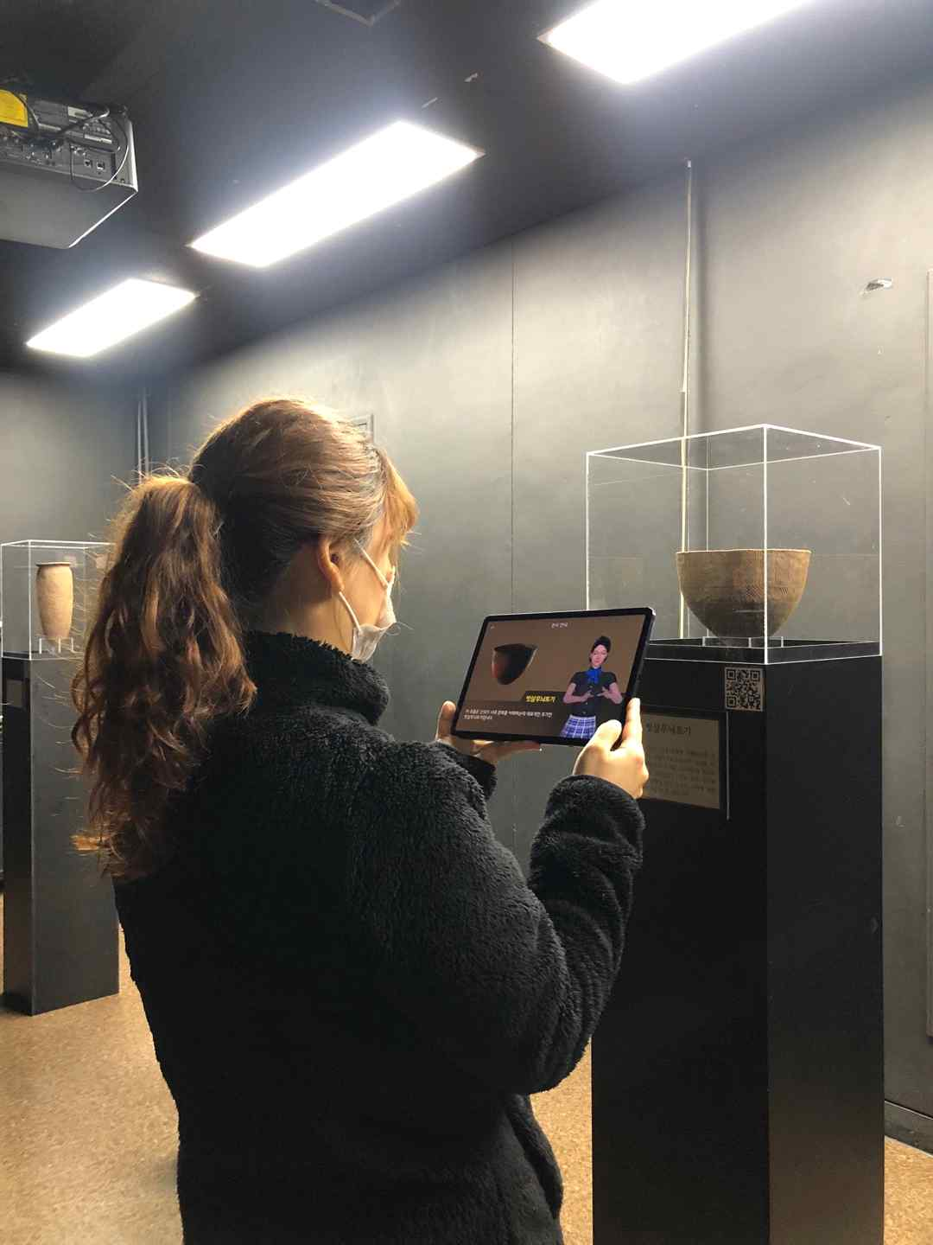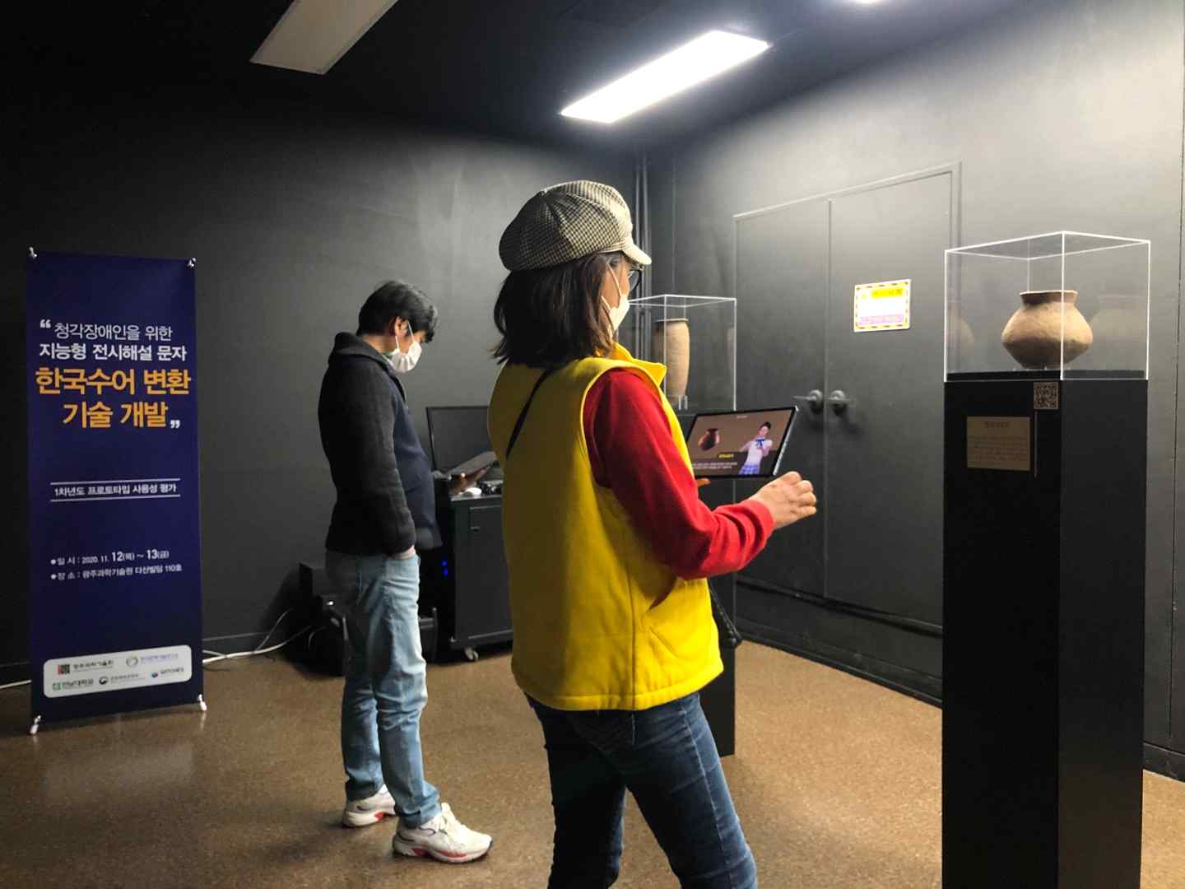

▲ GIST Korea Culture Technology Institute evaluates the usability of prototypes