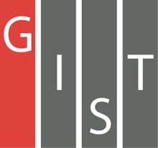

**Gwangju Institute of Science and Technology**

**Official Press Release (https://www.gist.ac.kr/)**

**Section of** Mi-Yeon Kim Nayeong Lee

**Public Affairs** Section Chief Senior Administrator

(+82) 62-715-2020 (+82) 62-715-2024

**Contact Person** Ji-young Park, Administrator

**for this Article** Advanced Photonics Research Institute

(+82) 62-715-3332

**Release Date** 2018.07.19

**GIST Advanced Photonics Research Institute hosts Summer School for Laser and Laser Applications (SSOLLA 2018)**

□ GIST (President Seung Hyeon Moon) – Advanced Photonics Research Institute (APRI, Director Hyyong Suk) invited students and researchers from all over the world to participate in the Summer School for Laser and Laser Applications (SSOLLA 2018) from July 9 to 13, 2018, which ended successfully.

□ APRI has held a summer school for graduate students and young researchers all over the world for eight years starting in 2010 and has trained 182 people so far. The summer program has grown into a mecca for photonics education.

∘ This year, the 9th SSOLLA hosted about 20 students and researchers from Asia, Europe, the Americas and Africa and conducted educational programs.

□ This summer, GIST professors and nine researchers from APRI participated in a variety of lessons ranging from lasers to applications such as laser safety, optics and nano optics, nonlinear optics, spectroscopy, and optoelectronics. Participants also conducted experiments in five areas, including interferometers and solid state lasers.

□ The participants were surprised by a very good research facility during their tour, they said that this summer's school program provided them with a great and valuable training experience in laser and laser applications.

□ APRI Director Hyyong Suk said, "APRI intends to cooperate closely with the participants of the Summer School for Laser and Laser Applications and the researchers from participating institutes in further contributing to the development of photon science and photovoltaics."

□ The GIST Advanced Photonics Research Institute (APRI) is the only specialized photonics research institute in Korea and has developed the world's first laser of 20 femtoseconds/4.2 peta watts since its establishment in 2001. APRI researchers have published many excellent papers in authoritative journals such as Nature and has been leading academic-industrial cooperation by transferring special optical fiber manufacturing technology to large domestic enterprises.

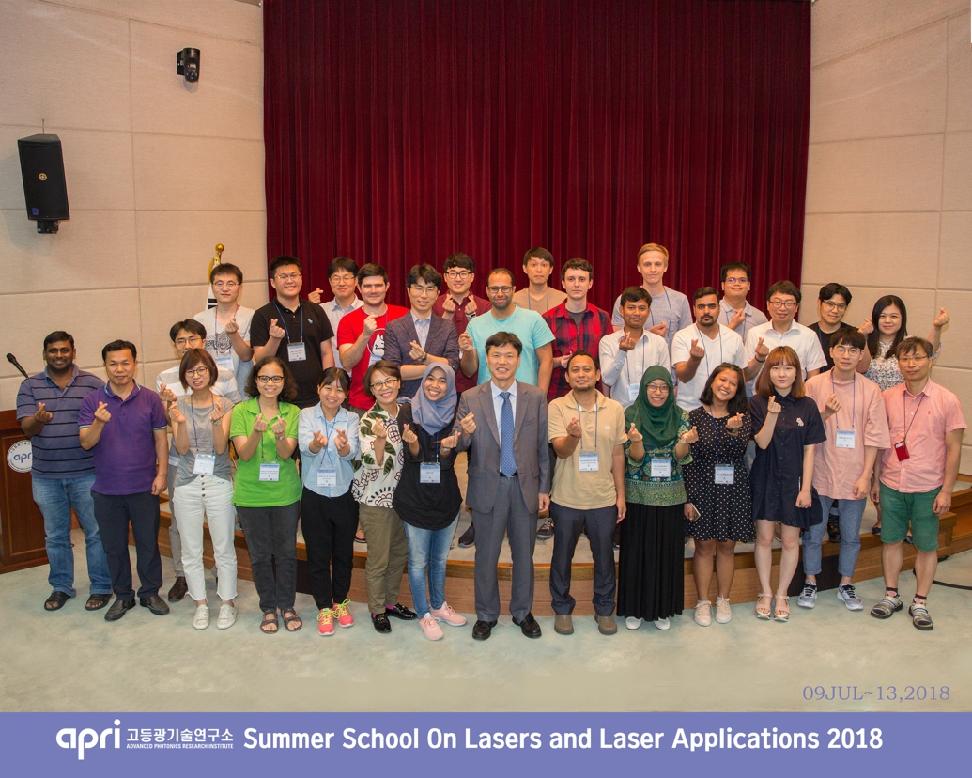

▲ SSOLLA 2018 Closing Ceremony