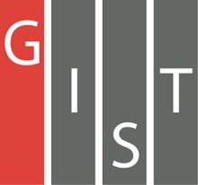

**Gwangju Institute of Science and Technology**

**Official Press Release (https://www.gist.ac.kr/)**

**Section of** Hyo Jung Kim Nayeong Lee

**Public Relations** Section Chief Senior Administrator

(+82) 62-715-2061 (+82) 62-715-2062

**Contact Person** Deuk-jo Gong, Senior Researcher

**for this Article** GIST Institute for Artificial Intelligence

062-715-2934

**Release Date** 2020.09.25

**GIST to hold AI startup competition**

**(Dreaming Child AI)**

□ Under the 'Artificial Intelligence-oriented Industrial Convergence Complex Development Project' promoted by the Ministry of Science and ICT and the Gwangju Metropolitan City, an AI start-up competition (Dreaming Child AI) hosted by the Artificial Intelligence Industry Convergence Project (Director Cha-Sik Lim) and conducted by GIST (Gwangju Institute of Science and Technology, President Kiseon Kim) and the Artificial Intelligence Research Institute (Director JongWon Kim) will be held.

∘ This contest aims to induce successful entrepreneurship as well as discover skills required by businesses by solving current issues facing companies from idea formation to business model creation.

□ The'Dreaming Child (AI)' contest is held in cooperation with foreign companies such as NVIDIA, Intel, AWS, and domestic companies such as LG Electronics and CJ OliveNetworks and proceeds in a way to solve a company's current problems utilizing data. The 2020 competition will focus on major regional industries, such as health care, and the preliminary and final rounds will be held for each event, focusing on mobility, energy, home appliances, and culture.

∘ The competition, which will start in earnest from October, is expected to be the largest in Korea with a total prize money of about 234 million won. In the preliminary round, the ability of prospective entrepreneurs to demonstrate convergence services for each AI category will be evaluated, and 32 teams will be selected to advance to the final round. In the finals, comprehensive AI convergence service design capabilities and verification of startup/collaboration items will be evaluated through a tournament method. Excellent participating teams that are selected will be given benefits such as consulting for start-up and commercialization, support linkage for prototype production costs, matching needs with companies, and having space for start-ups

∘ Preliminary issues for each event include: ▲ NVIDIA, "Predicting and blocking the spread of viruses such as COVID-19 using AI GPU technology" ▲ LG Electronics, "Face and voice recognition that can be used in smart home appliances" ▲ Intel, "Flying drones accurately recognizes an object and designates the exact location in the GUI" ▲ AWS, "Designing an autonomous driving algorithm and mounting it on a deep racer simulator to drive on an offline track in the shortest time and using the correct path" ▲ CJ Olive Networks, "Detecting small stories in videos and automatically generating background music and virtual fitting."

□ The "Dreaming Child (AI)" contest is scheduled to accept online applications until October 9th, and the final winners of each category will be screened for the preliminary round mid-October and the final round in November finals. Participation registration and details can be found on the Dreaming Child (AI) website (dreamai.kr).

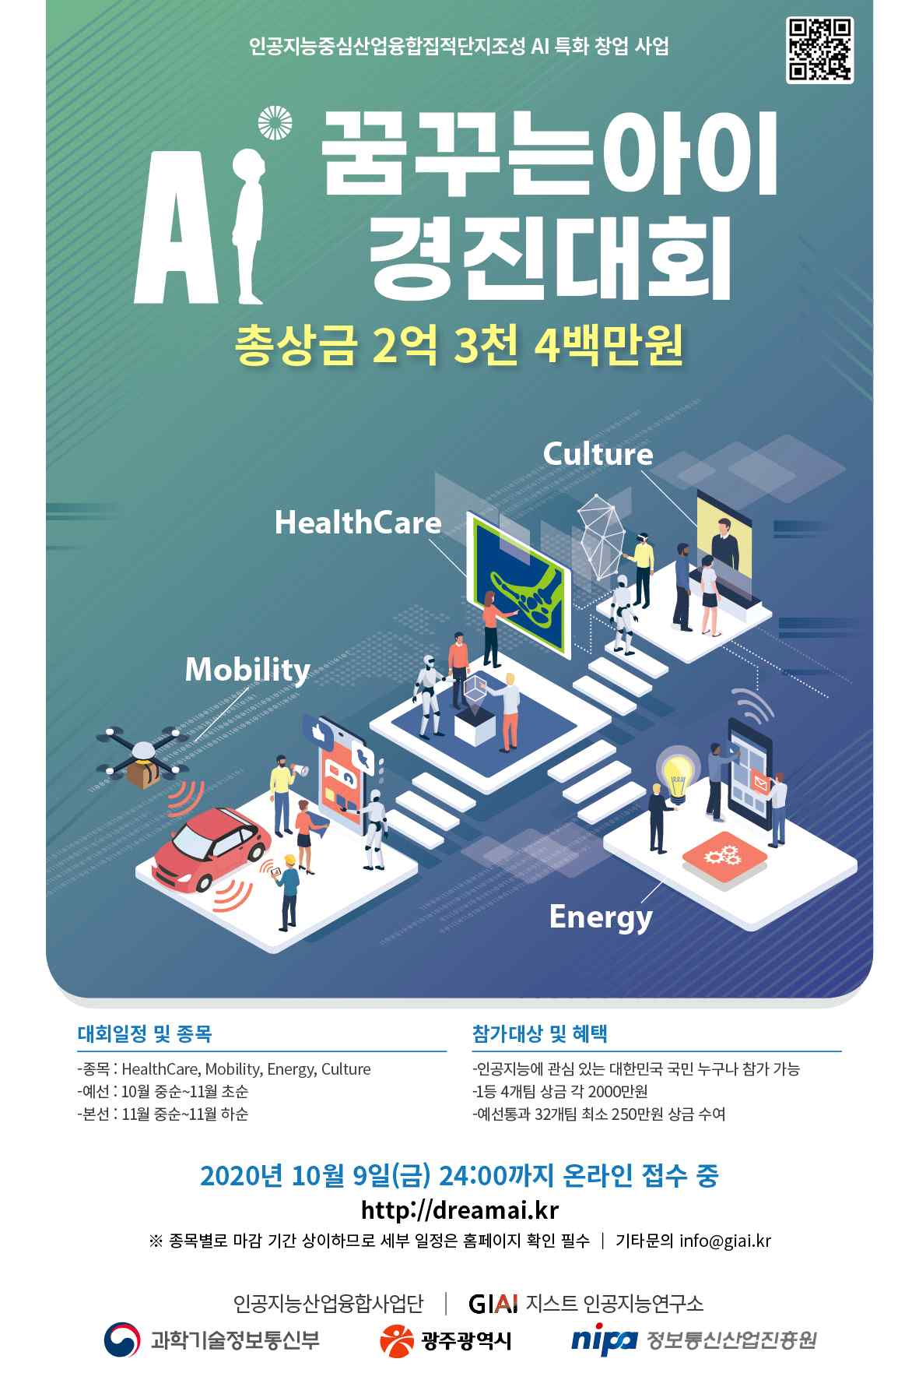

▲ Dreaming Child AI contest poster