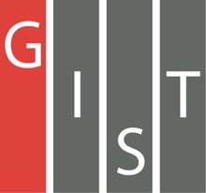

**Gwangju Institute of Science and Technology**

**Official Press Release (https://www.gist.ac.kr/)**

**Section of** Hyo Jung Kim Nayeong Lee

**Public Relations** Section Chief Senior Administrator

(+82) 62-715-2061 (+82) 62-715-2062

**Contact Person** You Seung Su, Administrator

**for this Article** Section of Public Affairs

062-715-2025

**Release Date** 2020.10.30

**GIST signs a business agreement for sustainable development with the Gwangju Metropolitan Council for Sustainable Development**

□ GIST (Gwangju Institute of Science and Technology, President Kiseon Kim) and the Gwangju Metropolitan Council for Sustainable Development (Chairman Young-il Chung) sign a business agreement (MoU) for Sustainable development.

∘ The signing ceremony was held with the participation of GIST President Kiseon Kim, Gwangju Metropolitan Council for Sustainable Development Chairman Young-il Chung, and other related parties.

∘ The contents of the agreement with the Gwangju Council for Sustainable Development include: ▲ development and promotion of programs to spread sustainable development goals (SDGs) ▲ joint cooperation related in social and school education for sustainable development (ESD) ▲ joint promotion of sustainable development-related projects ▲ sustainable development-related information exchange and shared use of the infrastructure ▲ other agreements between the two organizations.

□ GIST President Kiseon Kim said, "For sustainable development centered on the environment and people, GIST will do its best to conduct research and develop technologies to meet energy conservation and the Green New Deal."

□ Gwangju Metropolitan Council for Sustainable Development Chairman Young-il Chung said, "Through the agreement with GIST, there was an opportunity to incorporate sustainable development into school education. We look forward to achieving both sustainable development as well as pleasant environmental preservation and balanced development."

∘ Meanwhile, GIST is taking the lead in joining the community by signing business agreements with Gwangju and South Jeolla organizations such as Gwangju National University of Education, Jeollanam-do Office of Education, and the Kim Dae-jung Convention Center.

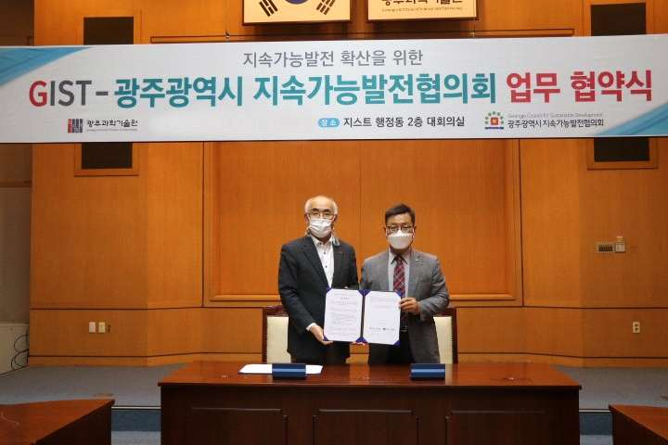

▲ [From left] GIST President Kiseon Kim and Gwangju Metropolitan Council for Sustainable Development Chairman Young-il Chung sign MoU for sustainable development