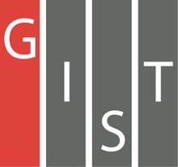

**Gwangju Institute of Science and Technology**

**Official Press Release (https://www.gist.ac.kr/)**

**Section of** Hyo Jung Kim Nayeong Lee

**Public Relations** Section Chief Senior Administrator

(+82) 62-715-2061 (+82) 62-715-2062

**Contact Person** Hyejin Lee, Administrator

**for this Article** Section of Public Affairs

062-715-2026

**Release Date** 2020.09.11

**GIST hosts online science camp for gifted students**

□ GIST (Gwangju Institute of Science and Technology, President Kiseon Kim) hosted the 'GIST Online Gifted Science Camp' for middle school students in the Honam area who are aspiring science students.

∘ The camp offered live online lectures on interesting science topics and online exams for participating middle school students for two days during summer vacation to prevent the spread of COVID-19.

□ The program included ▲ GIST introduction and Gifted Science Camp orientation (GiOnNaRae student ambassadors) ▲ Cosmic Croquis: Drawing with Physics (Department of Physics and Photon Science Professor Keun-Young Kim) ▲ The Brain: The Microcosm in Our Body (School of Life Sciences Professor Chul-Seung Park) ▲ MusiA-Artificial Intelligence: Falling into Music (AI Graduate School Professor Chang Wook Ahn) ▲ Nanobots that Roam in the Body and Heal (School of Integrated Technology Jung Won Yoon).

∘ From the results on the online test conducted on September 5, 2020, ▲ Sung Se-kyung of Geumdang Middle School in Gwangju received the President's Award ▲ Park Min-woo of Yudal Middle School in Mungpo received the Grand Prize ▲ Moon Soo-eon of Imsil Dong Middle School received the Excellence Prize ▲ Park Ji-hyun of the Yeosu Girls' Middle School received the Encouragement Prize ▲ Hwang Min-seo of the Sinji Middle School in Wando received the Encouragement Prize. In order to prevent the spread of COVID-19, a certificate of merit was sent to each school and the student received their prizes on September 10, 2020.

□ President Kiseon Kim said, "I hope that this will be an opportunity to improve creative thinking through special lectures on science in areas that students usually find difficult. GIST will pay more attention to the development of scientific culture and the cultivation of science students."

∘ Office of International and Public Affairs Dean Sung-Gyoo Park said, "The event was organized to encourage young dreamers who are interested in science to develop their understanding and interest in science. We will continue to be very interested in promoting GIST and actively explore interesting events that will give positive impetus to future scientists."

∘ One student who participated in the camp said, "I had a lot of questions about GIST, and it was nice to listen directly to GIST professor in live online lectures. I will continue to devote myself to my studies and will dream of studying myself at GIST's campus someday."

∘ Every student who participated in the camp was sent a GIST gift kit (certificate of completion, special school certificate, GIST leaflet, souvenirs, etc.) by mail.

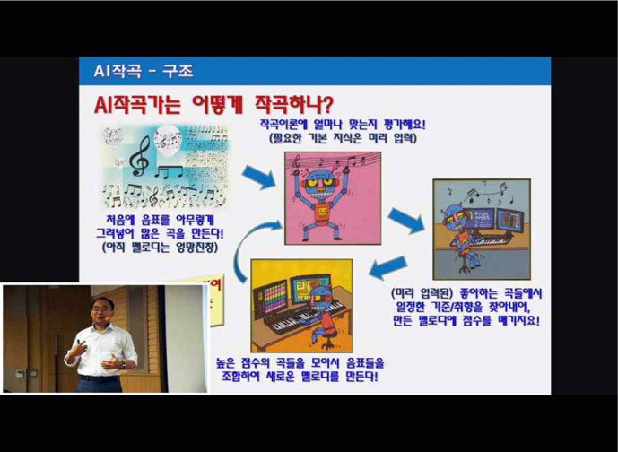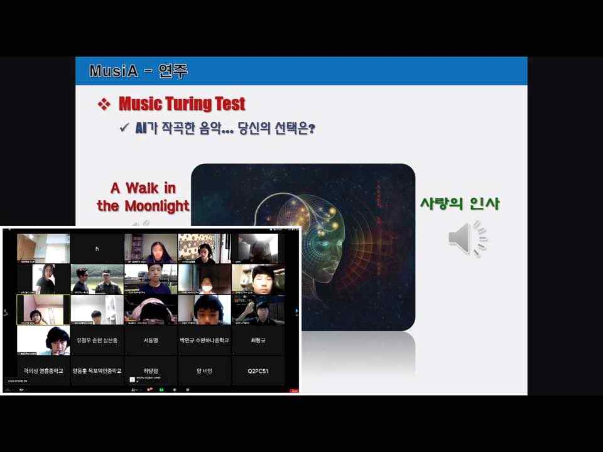

▲ Professor Chang Wook Ahn's live online lecture