

**Gwangju Institute of Science and Technology**

**Official Press Release (https://www.gist.ac.kr/)**

**Section of** Hyo Jung Kim Nayeong Lee

**Public Relations** Section Chief Senior Administrator

(+82) 62-715-2061 (+82) 62-715-2062

**Contact Person** Boo-kyung Kim, Administrator

**for this Article** Section of Student Services

(+82) 62-715-2053

**Release Date** 2020.03.11

**GIST will undergo 100% digital transformation**

**in response to the CORVID-19 challenge**

□ Gwangju Institute of Science and Technology (GIST, President Kiseon Kim) will conduct online lectures from the start of the semester on March 13, 2020, until the end of April if the situation has stabilized or until the end of the semester to preemptively prevent the spread of CORVID-19.

□ GIST will use Zoom and Skype, which are real-time video chat platforms, for online classes and will upload edited videos and external video clips directly to the GIST E-Learning System (GEL), a Moodle program-based self-directed online class system, and will use the forum function for questions and answers. GIST will also utilize existing learning materials such as MOOC and plans to use Zoom and Skype for real-time remote classes.

∘ In particular, GIST has conducted all courses in English since its opening, but for this semester, Korean classes are available for online lectures to maximize communication efficiency.

□ Accordingly, GIST held a two-day online lecture demonstration on March 11 and March 12, 2020, at the Oryong Hall for one-on-one tutoring.

∘ Participants are professors and assistants with lectures in the first semester, and all attendees were required to wear a mask and complete a temperature test with the thermal imaging camera installed at the entrance.

□ Office of Academic and Student Affairs Dean Kangwook Kim (School of Electrical Engineering and Computer Science professor) said, "With the health and safety of our members as the top priority, GIST will conduct online classes for all subjects starting in March. To ensure the robustness of online classes, we would like to hold a one-to-one tutoring session to eliminate any problems and difficulties that might arise when the classes are being taught online."

□ Meanwhile, GIST and other science institutes will also push for remote classes such as "real-time online lectures" to prevent the spread of the CORVID-19 virus.

∘ KAIST operates the KAIST Learning Management System (KLMS), which is a mix of 'non-real-time remote classes' with 'real-time classes' where professors and learners are simultaneously connected with videos produced by professors and questions are answered through bulletin boards. For real-time classes, Zoom will be used.

∘ DGIST and UNIST conduct real-time remote classes using the 'collaborate ultra' function provided by Blackboard. To increase efficiency of operation, cloud service is used so that real-time lectures can be delivered in a stable manner regardless of the number of simultaneous users. Existing methods such as recording and registering materials for lectures in advance or utilizing MOOC will also be used.

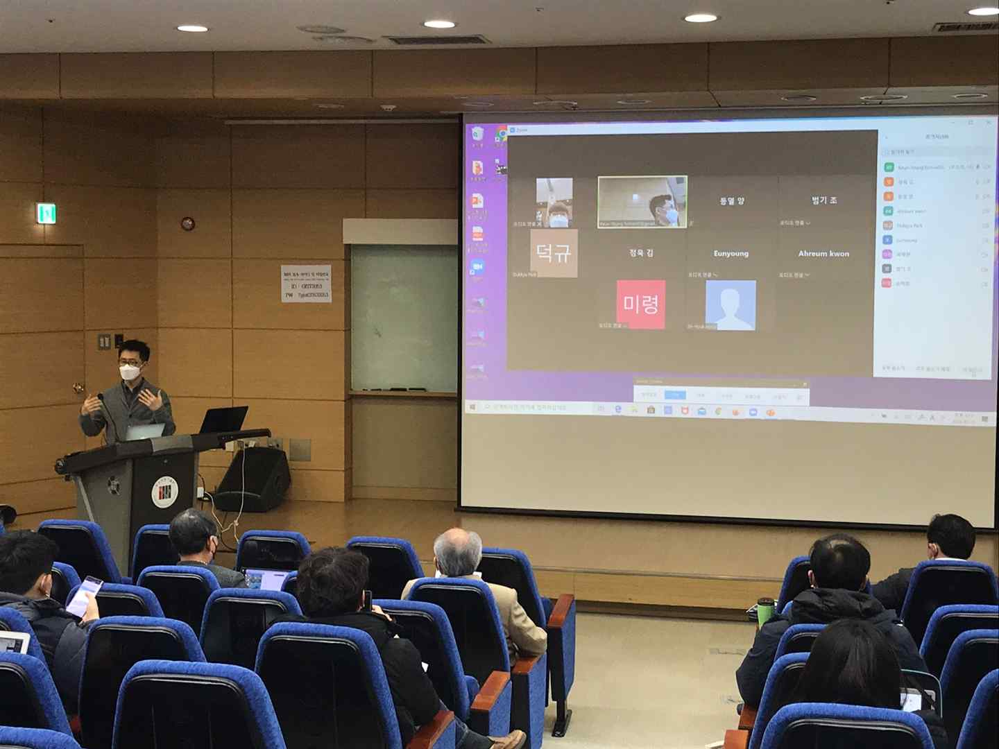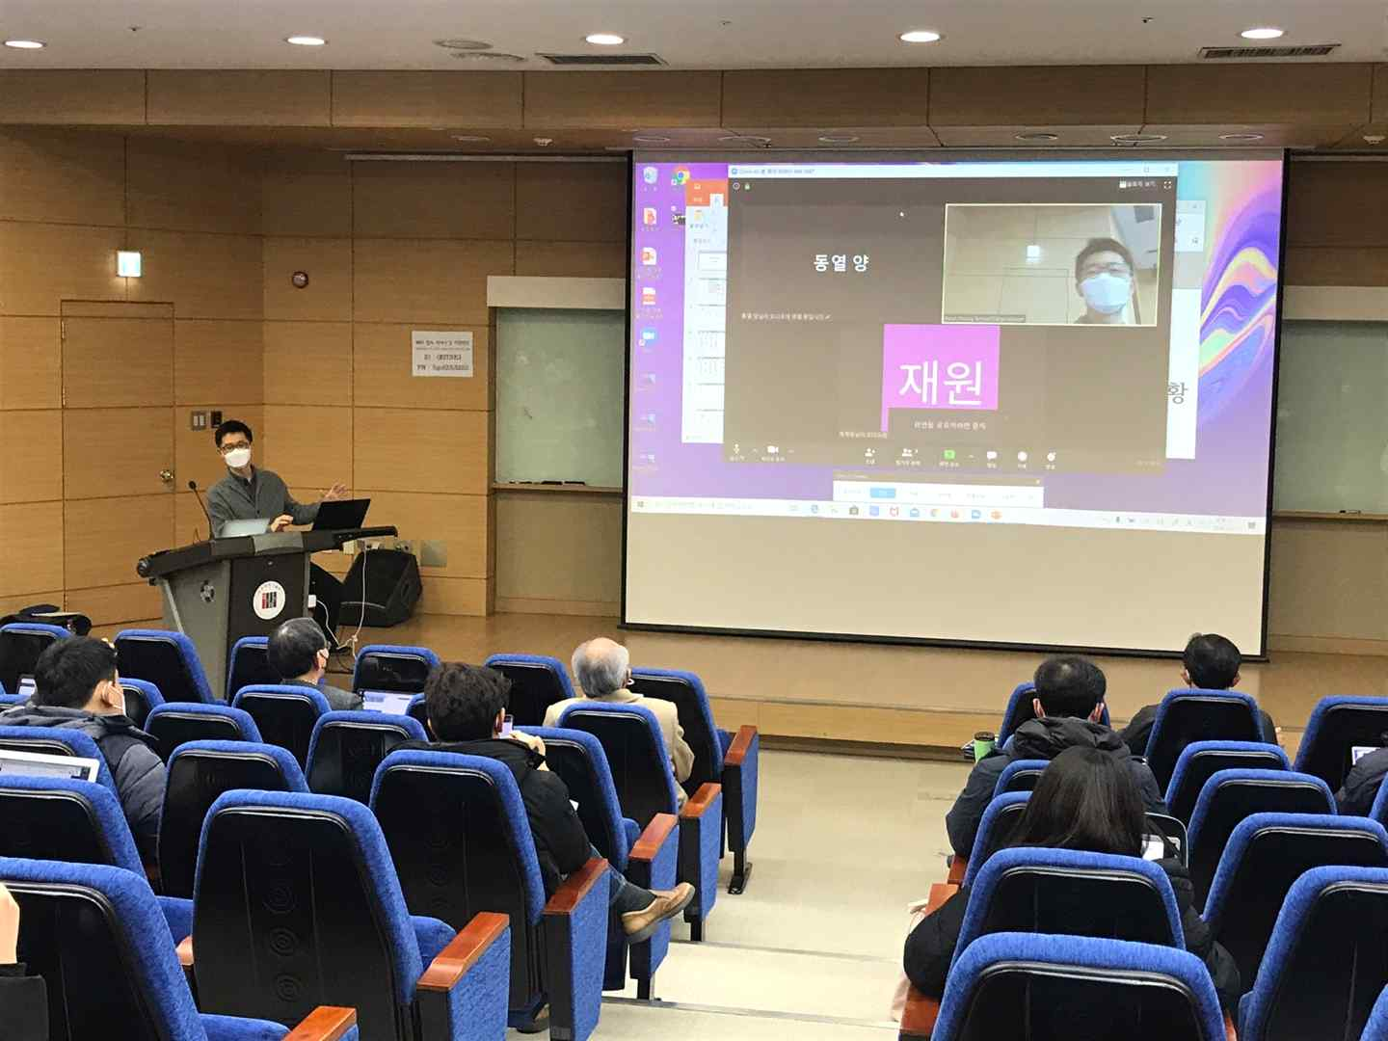

▲ Professor Keun-Young Kim demonstrates giving a

lecture on Zoom, a real-time video chat platform