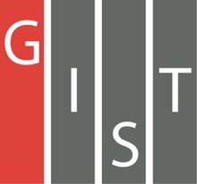

**Gwangju Institute of Science and Technology**

**Official Press Release (https://www.gist.ac.kr/)**

**Section of** Hyo Jung Kim Nayeong Lee

**Public Relations** Section Chief Senior Administrator

(+82) 62-715-2061 (+82) 62-715-2062

**Contact Person** Moon-seob Yoon, Administrator

**for this Article** Section of Public Affairs

062-715-2021

**Release Date** 2020.12.01

**Woosung Corporation Co., Ltd., Chairman Hwa-seok Park donates 20 million won for GIST undergraduate scholarships**

□ GIST (Gwangju Institute of Science and Technology, President Kiseon Kim) received 20 million won for GIST undergraduate scholarships on November 30, 2020, from Woosung Corporation Co., Ltd., Chairman Hwa-seok Park.

∘ Woosung Corporation Co., Ltd., Chairman Hwa-seok Park is the current director of the GIST Development Foundation and completed the 1st GIST MBA course. Since 2017 and in connection with the Gwangju Social Welfare Association (Fruits of Love), he has provided scholarships ever year to GIST undergraduate students, and his total donation amount, including this scholarship of 20 million won, has reached 51 million won.

□ Chairman Hwa-seok Park made technical alliances with leading overseas companies such as in Sweden and Japan with unrivaled multi-injection mold technology, and Woosung Precision and New Mold Co., Ltd., supply molds to leading domestic companies such as Samsung Electronics and Hyundai Mobis. He is a professional manager representing the Gwangju region by leading the company. In addition to the award from the Minister of SME and Startups as an excellent company in 2017, he is currently the chairman of the Korea Mold Industry Promotion Association and is striving for the development of the Korean mold industry.

∘ Chairman Hwa-seok Park said, "With love and affection for the education provided by the local university, I wanted to find new ways to support GIST, the birthplace of Gwangju's specialists. I hope that this will help GIST College students dream about making a huge impact on the world stage."

∘ GIST College Dean Sungho Jeong, who received the donation, said, "We will use the donation responsibly to help GIST undergraduates become more resourceful specialists."

□ The donation ceremony was a simple affair that was carried out safely by adhering to Covid-19 safety guidelines with participation by a limited number of people.

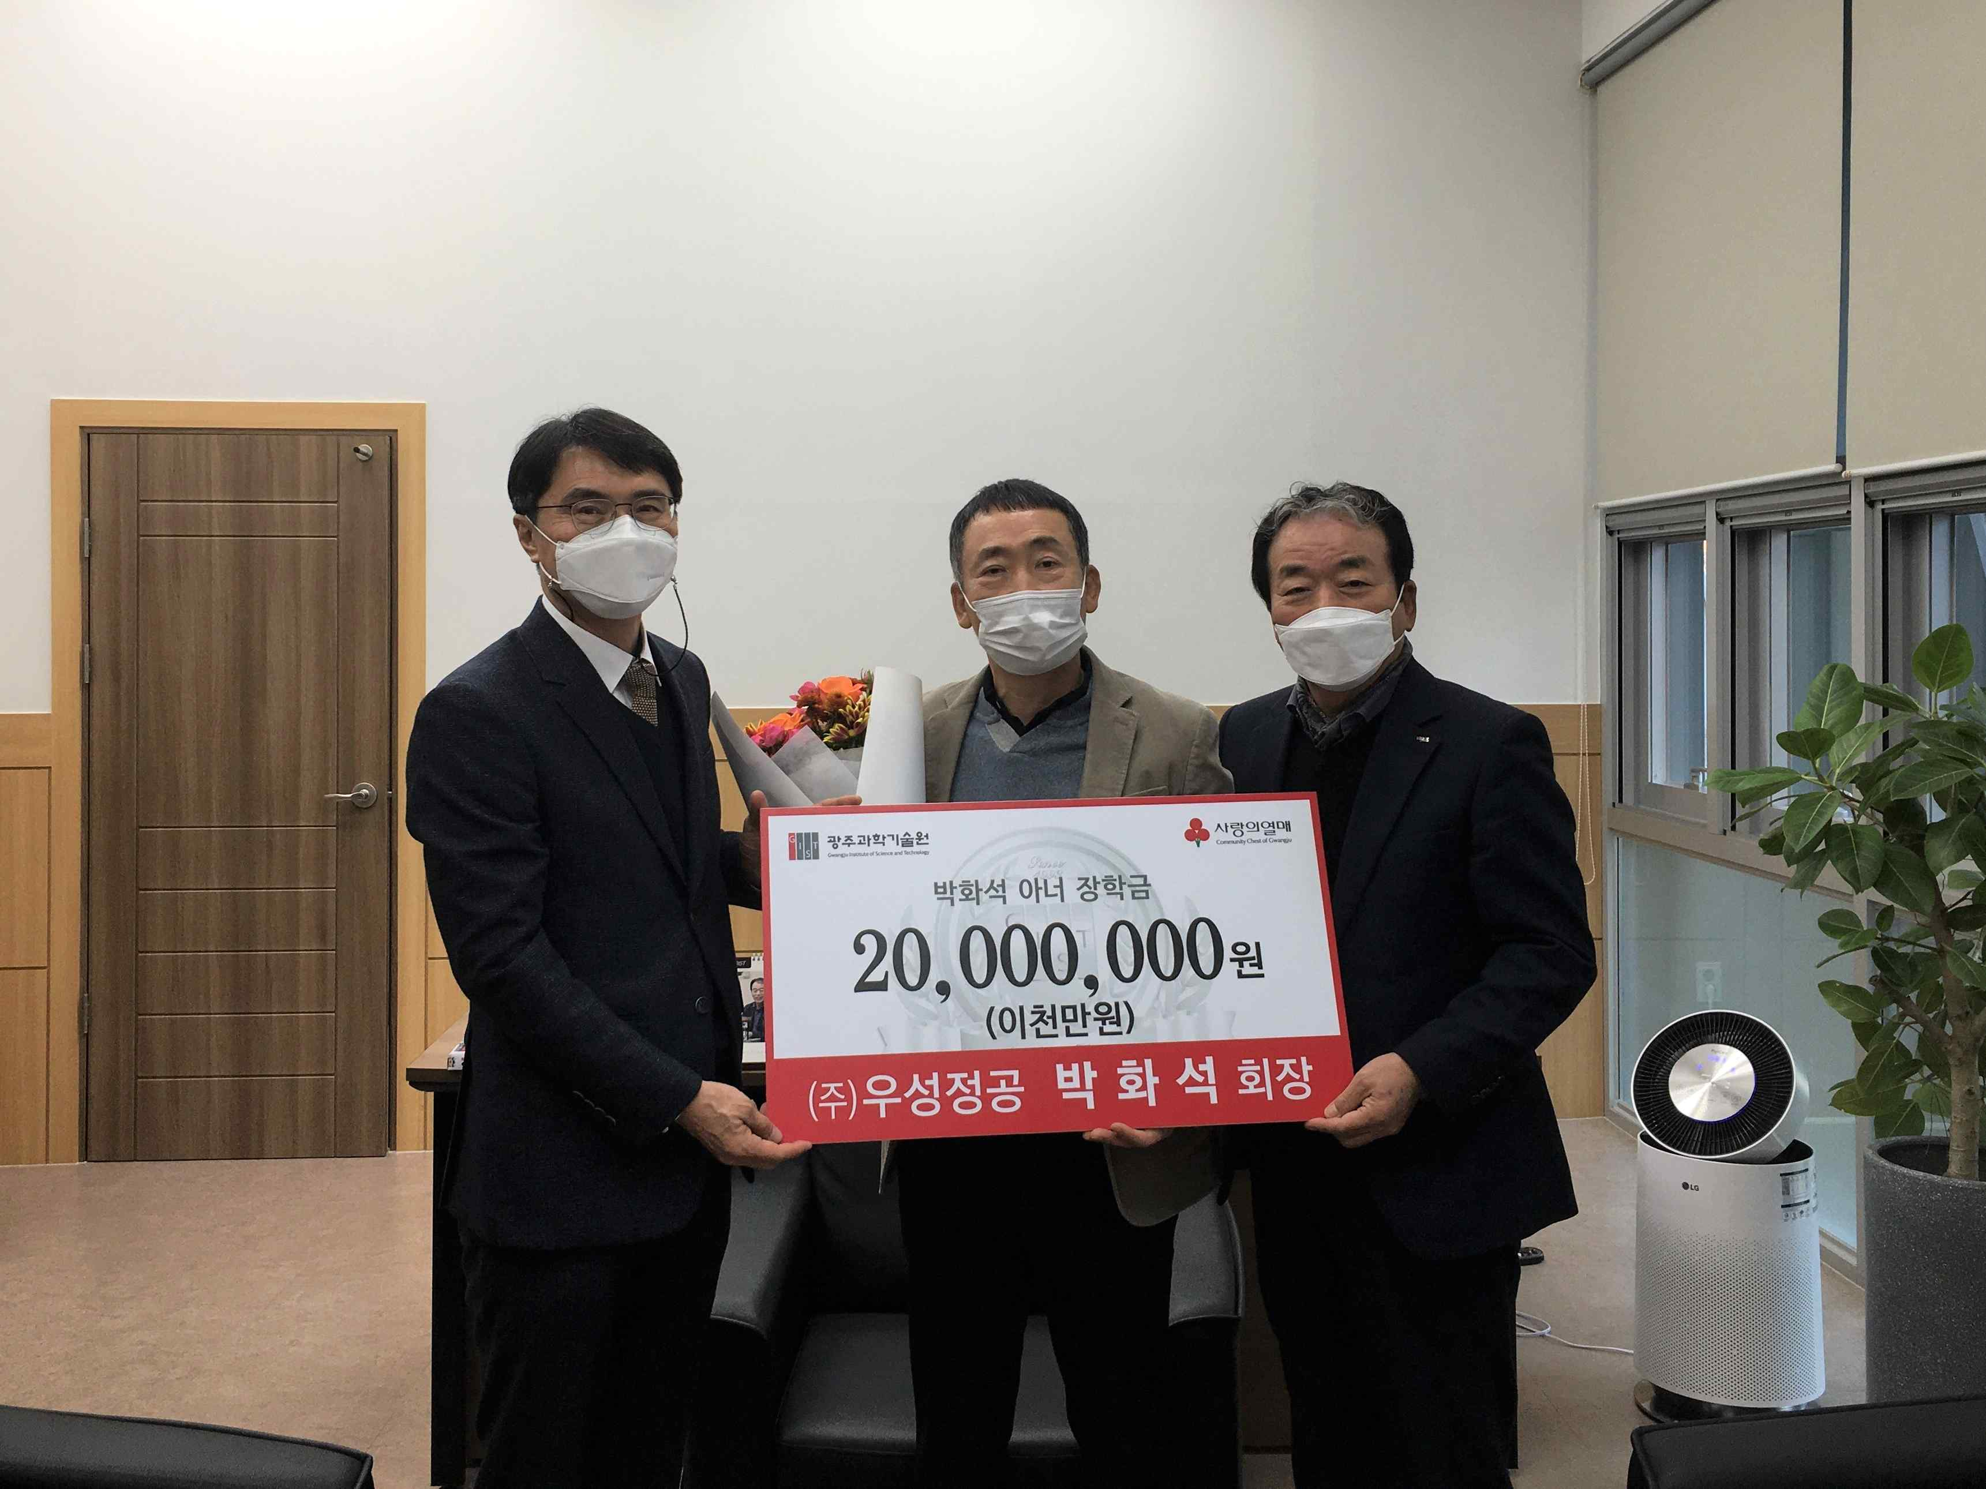

▲ [From left] GIST College Dean Sungho Jeong, Woosung Corporation Co., Ltd.,

Chairman Hwa-seok Park, and Nayoung Industry Co., Ltd., Chairman Jeong-ju Jeong