

**Gwangju Institute of Science and Technology**

**Official Press Release (https://www.gist.ac.kr/)**

**Section of** Hyo Jung Kim Nayeong Lee

**Public Relations** Section Chief Senior Administrator

(+82) 62-715-2061 (+82) 62-715-2062

**Contact Person** Seung-soo Yoo, Administrator

**for this Article** Section of Public Affairs

(+82) 62-715-2025

**Release Date** 2020.04.27

**GIST and Jeollanam-do sign agreement to attract next-generation radiation accelerators to Honam**

□ GIST (Gwangju Institute of Science and Technology, President Kiseon Kim) and Jeollanam-do (Governor Young-rok Kim) signed an MoU for joint cooperation on the next generation of radiation accelerators *.

* The radiation accelerator is a state-of-the-art device that accelerates charged particles such as electrons or protons at a speed of light using a powerful electric field. The next-generation radiation accelerator is a super-large circular radiation accelerator with up to 1,000 times the brightness and cohesion of light compared to third-generation radiation accelerators and has more than 60 beam lines in the experimental space that can observe light. It is used in various fields ranging from basic science to applied science and industrial development and is a key infrastructure for future industrial development, especially securing global competitiveness in the semiconductor industry.

∘ The signing of the MoU by both agencies was carried out at separate locations in accordance with the implementation of social distancing to prevent the spread of COVID-19.

□ This agreement aims to attract accelerators to the Honam region (Jeonbuk, Gwangju, and Jeonnam) and to Naju, Jeollanam-do, a joint innovation city of Gwangju and Jeonnam.

∘ If the radiation accelerator is established in the Honam region, it is expected that the core industries in the Honam region, such as artificial intelligence (AI), automobile industry, new energy materials, and medical bio industries, will take a big leap forward by greatly expanding the foundation of the materials, parts and equipment industry, which are national tasks as well as balanced national development. In particular, it is expected that linking the radiation accelerator around GIST, the only science and technology-specific university in the Honam region, will increase its advanced research capabilities and preempt future core technologies.

□ The main points of the agreement include ▲ strengthening research capabilities using the next generation radiation accelerator and best support for maximum performance ▲ using the next generation radiation accelerator for research and development in new fields and to train the next generation of outstanding research personnel ▲ cooperation for mutually beneficial development related to the use of next-generation radiation accelerators.

□ GIST President Kiseon Kim said, "The Honam region has the optimal location for constructing next-generation radiation accelerators, including stable grounds, large sites, abundant AI infrastructure, and advanced human resources. If the next-generation radiation accelerator is made in our region, it will be expected to strengthen the competitiveness of universities by securing international research capabilities and nurturing next-generation global research personnel."

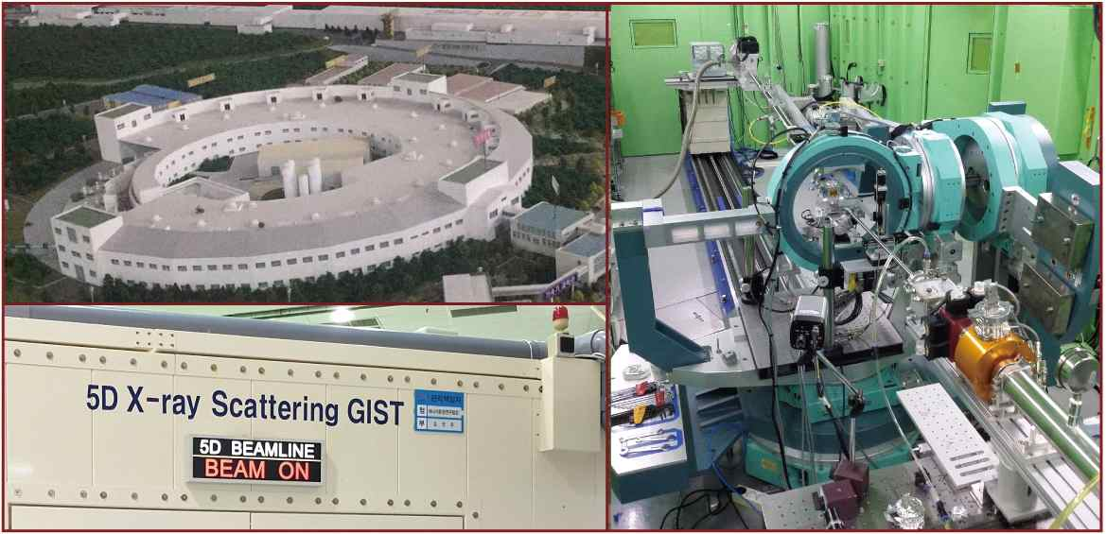

▲ GIST built beam line at Pohang radiation accelerator: Equipment for

observing ultra-fine phenomena of materials using X-rays