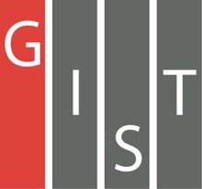

**Gwangju Institute of Science and Technology**

**Official Press Release (https://www.gist.ac.kr/)**

**Section of** Hyo Jung Kim Nayeong Lee

**Public Relations** Section Chief Senior Administrator

(+82) 62-715-2061 (+82) 62-715-2062

**Contact Person** Semi Park, Administrator

**for this Article** Section of Public Relations

(+82) 62-715-2960

**Release Date** 2020.03.24

**GIST PRESS publishes 'The Old**

**Story of a High-Tech Village in Bia'**

□ A book has been published to awaken the nostalgia of those who lived in the old village of Bia in Gwangju and to promote understanding and attachment of the current residents living in the community.

□ Gwangju Institute of Science and Technology (GIST, President Kiseon Kim) GIST PRESS has published 'The Old Story of a High-Tech Village in Bia' by Joon-soo Park (Gwangju Daily Newspaper), which describes the past history of an old village in Bia, which was incorporated into the Gwangju high-tech science area.

∘ The book is composed of five parts. ▲ Part 1 is about the origin of Bialand, ▲ Part 2 is about its modernization and the establishment of Bia's elementary, middles, and high school, ▲ Part 3 is about its development into a high-tech science area along with the influx of migrants, ▲ Part 4 is about Bia's unique specialties and historical heritage, such as radish, pear, makgeolli, and onggi, and ▲ Part 5 contains the residents' recollections of their hometown and the current village culture of the community.

□ The region of Bia, where GIST is located, was a typical rural village until the development of a high-tech area in 1993, and it had a long-standing agricultural history since prehistoric times. Geographically, it is located on a path in Gwangju, adjacent to the Yeongsan River basin, and has formed a unique history and culture due to its lack of exchange with other regions. In particular, the passage of the National Road No. 1 in the process of modernization led to significant changes in the community, with the Japanese creating an orchard field.

∘ Due to the characteristics of it location, in accordance with the government's policy to create a high-tech science area in the 1990s, a state-of-the-art complex was built to transform it into an area that plays a pivotal role in Gwangju's production and urbanization. However, due to the rapid development, the scenery of the village disappeared with the original local residents being scattered and the area transformed into a completely new city. At the same time, the history and customs of the village residents came to an end.

□ GIST President Kiseon Kim said, "This book will help to restore cultural solidarity with local residents by reminding them of Bia's past nostalgia while giving current residents a sense of historical perspective of Bia and it rapid development. Also, I hope that this will serve as a bridge to communicate and build relations with the local community."

□ 'The Old Story of a High-Tech Village in Bia' can be purchased at online and offline bookstores and will be distributed to public libraries in the region.

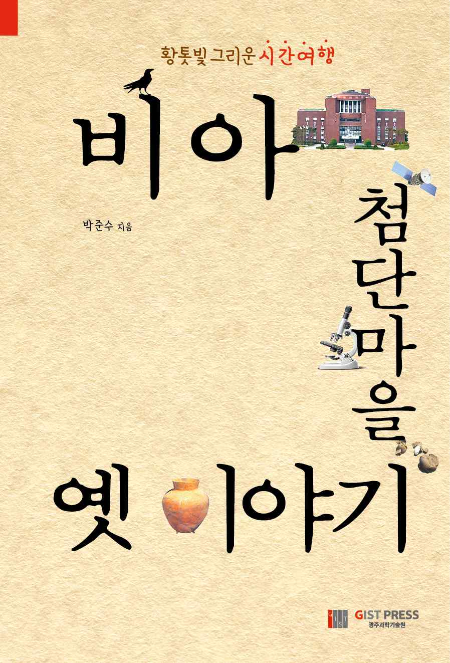

▲ Book cover / Author Joon-soo Park (Chief Editor of the Gwangju Daily Newspaper)