

**Gwangju Institute of Science and Technology**

**Official Press Release (https://www.gist.ac.kr/)**

**Section of** Hyo Jung Kim Nayeong Lee

**Public Relations** Section Chief Senior Administrator

(+82) 62-715-2061 (+82) 62-715-2062

**Contact Person** Chang-sung Kang, Administrator

**for this Article** Business Support Center

062-715-6303

**Release Date** 2020.11.20

**GIST completed '2020 Regional**

**Entrepreneur Experience Center'**

□ GIST (Gwangju Institute of Science and Technology, President Kiseon Kim) provided entrepreneurship education and practical training using mandarat (lotus technique) * to third-year students of Munseong Middle School (Bongseon-dong) in Gwangju.

* Mandarat is an idea technique developed by Japanese designer Hiroaki Imaizumi in 1987 that helps to come up with various ideas in the shape of a blooming lotus.

∘ The Regional Entrepreneur Experience Center utilizes the infrastructure of the community to operate a specialized creative experience program to support the operation of school start-up experience education and to establish a network in the area. By establishing a systematic cooperative system inside and outside the school, it also actively supports students to grow into future innovative talents through richer experiences.

□ To prevent the spread of Covid-19, social distancing rules were followed and 160 students from six classes in the third year of Munseong Middle School were provided with entrepreneurship education and practical training for expansion of start-up ideas using mandarat in four classes from November 2 to 9, 2020.

∘ Each group of 5 to 6 students expands ideas through mandarat and shared ideas and ideas with other teams through three-minute skits to encourage students to be interested in starting a business without being bored.

∘ A student who participated in the educational program said, "At first, I was not interested in starting a business because I was unfamiliar with the word entrepreneur, but it was so much fun as I was able to approach it more easily with my friends."

□ Business Support Center Director Byeong-kwan Jo said, "e intend to spread the right creative mindset so that youths in Gwangju can grow into innovative future talents with creativity and a spirit of challenge. GIST will provide continuous start-up education to help students set their career paths and develop entrepreneurship."

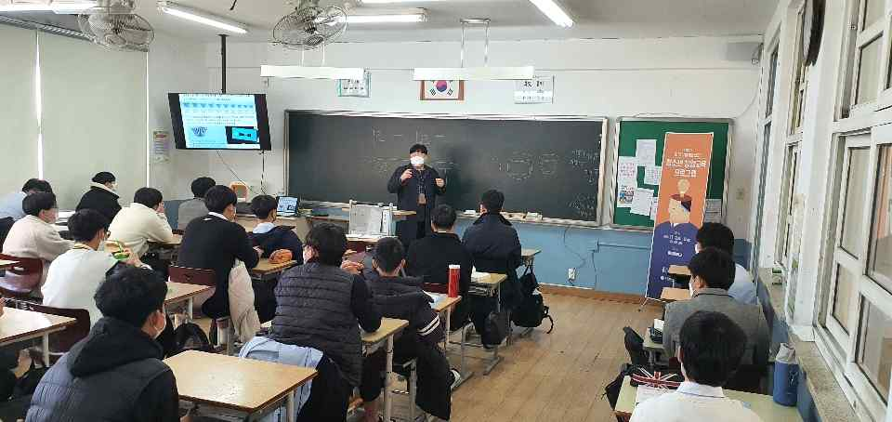

▲ GIST '2020 Regional Entrepreneur Experience Center' education