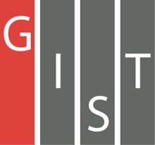

**Gwangju Institute of Science and Technology**

**Official Press Release (https://www.gist.ac.kr/)**

**Section of** Hyo Jung Kim Nayeong Lee

**Public Relations** Section Chief Senior Administrator

(+82) 62-715-2061 (+82) 62-715-2062

**Contact Person** Moon-sub Yoon, Administrator

**for this Article** Section of Public Affairs

(+82) 62-715-2021

**Release Date** 2020.06.15

**GIST donates masks to local child centers**

**to prevent the spread of COVID-19**

□ GIST (Gwangju Institute of Science and Technology, President Kiseon Kim) donated masks to 27 children's centers on June 12 to prevent the spread of COVID-19.

∘ GIST's Section of Public Affair conducted a Good Mask Sharing Campaign for GIST members for two weeks from May 15 to May 29. Faculty, students, and staff, as well as a donation of 200 masks from Purify Techno, a research institute company, joined resources to deliver masks to students at children's centers in Gwangju.

□ The mask delivery ceremony for preventing the spread of COVID-19 was simplified selecting one local children's center near GIST with masks being delivered to the other children's center by couriers.

∘ The head of a local children's center that received masks said, "During this difficult period of another wave of COVID-19, we are grateful that GIST is taking the lead in helping local students."

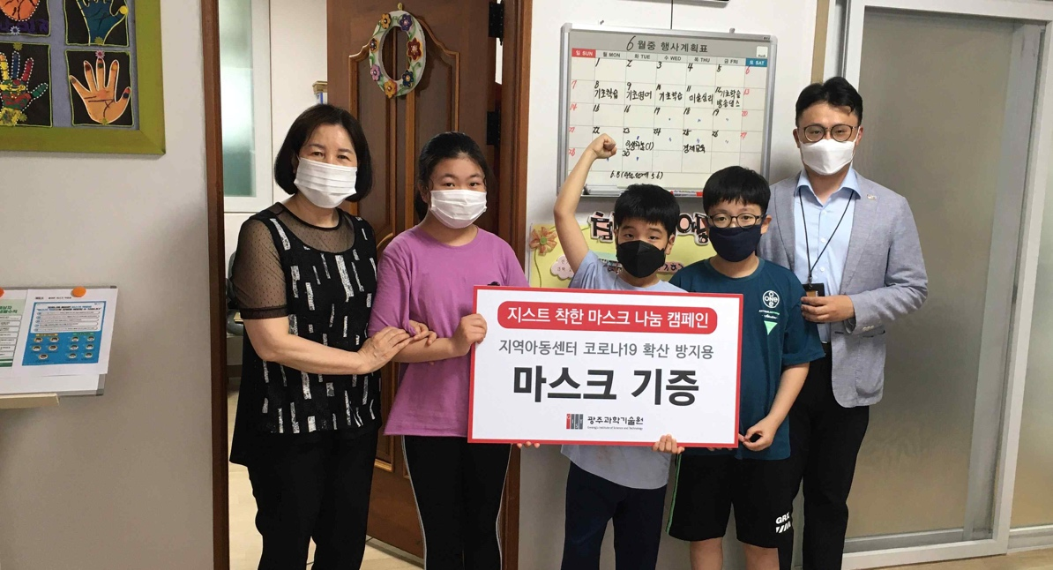

[Photo] GIST delivers masks to preven COVID-19 to a local children's center