

**Gwangju Institute of Science and Technology**

**Official Press Release (https://www.gist.ac.kr/)**

**Section of** Hyo Jung Kim Nayeong Lee

**Public Relations** Section Chief Senior Administrator

(+82) 62-715-2061 (+82) 62-715-2062

**Contact Person** Kyung-woong Kim, Director

**for this Article** International Environmental Research Institute

(+82) 62-715-3391

**Release Date** 2020.03.09

**GIST signs agreement with AMOTECH to**

**support global talents with scholarships**

□ Gwangju Institute of Science and Technology (GIST, President Kiseon Kim) International Environmental Research Institute (Director Kyung-woong Kim) has signed an agreement with AMOTECH (Chairman Byung-kyu Kim) to support global talents with scholarships at the AMOTECH-GIST International Environmental Research Institute.

∘ This scholarship will support 15 students over a five-year period by selecting three international students a year from the master's and doctoral degree programs at GIST to foster global talents and strengthen their international capabilities. The ceremony was held on March 9 at the Le Méridien Hotel.

□ GIST, a research institute under the Ministry of Science and Technology, has a total of 125 international students in its graduate program for masterss and doctoral degrees from countries such as the United States, Vietnam, Philippines, Pakistan, Bangladesh, and Mongolia. In addition to providing dormitories to all international students, they are also provided with generous benefits such as full tuition exemption, student stipends, and one-way airfare reimbursement.

∘ So far, a total of 438 foreign students (301 master's and 137 PhDs) have graduated from GIST, and many are professors at outstanding domestic and foreign universities, including Hanoi University of Science and Technology, Malaysian University of Technology, UNIST, Hanyang University, Inha University, and Hankuk University of Foreign Studies. In addition, GIST's status has been enhanced by graduates working at overseas research institutes or starting a business, like in India.

∘ AMOTECH was established in 1994 and is an electronic communications component manufacturer that developed and provided key components for information communication, IT appliances, and energy based on new materials. In 2019, it was awarded the "Outstanding Quality Award" by Fiat Chrysler. Also, to solve the water problem, AMOTECH has donated free gravitational membrane filtration devices to more than 10 countries in collaboration with the International Environmental Research Institute.

□ GIST President Kiseon Kim said, "I hope that this agreement will lead to the discovery and development of outstanding foreign students in the field of science who will have a crucial role in the further development of science and technology as well as helping to expand the Korean Wave."

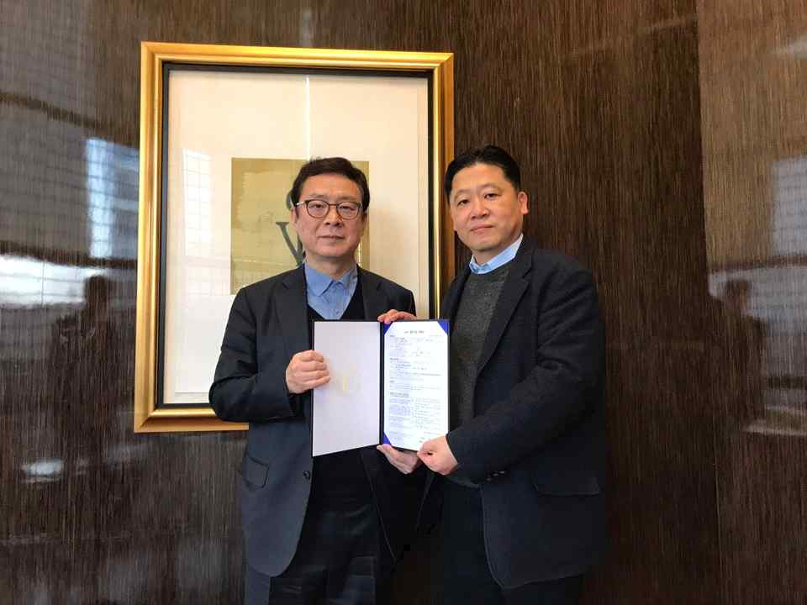

(From left) AMOTECH Chairman Byung-kyu Kim and GIST International

Environmental Research Institute Director Kyung-woong Kim