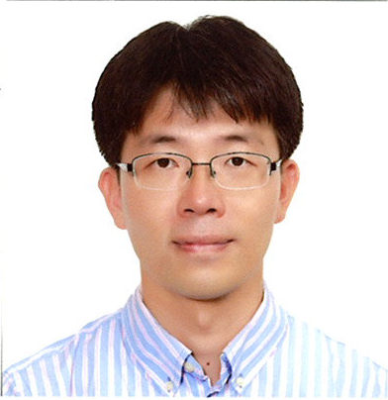
Seong Ku Lee

Principal Research Scientist
Advanced Photonics Research Institute
Gwangju Institute of Science and Technology
Office: +82-62-715-4715
Fax: +82-62-715-4707
Email: lsk@gist.ac.kr
Web: http://apri.gist.ac.kr

He received his Bachelor’s degree in physics from the POSTECH, S. Korea in 1998 and his Master’s degree in physics from the KAIST, S. Korea, in 2000. He earned his doctorate in physics from the KAIST, in 2005, and did post-doctoral work at the Institute of Laser engineering, Osaka University, Japan, in 2005-2006. He was a Senior Research Scientist at the APRI for 10 years. He is currently a Principal Research Scientist and a group leader of an ultra-intense laser group at the APRI. He is also a Visiting Research Fellow at the Institute for Basic Science, S. Korea. His research interests cover the various high-power solid-state lasers.

